**Azure Functional Specification**

*This Version of the documents isn’t yet complete and contains a subset of all sections only*

**Change Record**

|  |  |  |  |
| --- | --- | --- | --- |
| Date | Author | Version | Change Reference |
| 2018-12-03 | Felix Bodmer | 0.1 | Initial version |
| 2018-02-14 | Felix Bodmer | 0.2 |  |
|  |  |  |  |
|  |  |  |  |

Table of Contents

1 Introduction 5

1.1 Documentation Structure 6

1.2 Foundation Setup and Portfolio Management 8

1.3 Roles and Responsibilities 9

1.4 Architecture Review 10

1.5 Ordering Elements 10

1.6 Agility vs. Control 11

2 Subscriptions 12

2.1 Microsoft Azure Enterprise Portal 12

2.2 Azure Subscription Model 14

2.2.1 Resource Groups 16

2.3 Subscription Naming Convention 17

2.3.1 Supporting Tenants 17

2.4 RBAC 18

2.5 Policies 18

2.6 Quota Increase 18

2.7 CMDB 18

2.8 Subscription Monitoring and Alerting 21

2.8.1 Security Monitoring 21

2.8.2 Availability and Performance Monitoring 21

3 Naming Standards 23

4 Azure Active Directory 24

4.1 O365 Tenant vs. Azure Active Directory Instance 24

4.2 Domain Join to on-premise AD 24

4.3 Azure Active Directory instances used 25

4.4 Additional AAD Instances 26

4.5 AAD Monitoring and Alerting 27

5 RBAC 28

5.1 Inheritance 28

5.2 Deny Assignment – Preventing Inheritance 29

5.3 Privileged Identity Management 30

5.4 Mapping of 30

6 Policies 32

6.1 Policy Levels 32

6.2 Policy Definition Process 33

7 Tagging 34

7.1 Resource Groups 34

7.2 Resources 34

7.3 Tag Management 35

8 Automation Framework 36

8.1 CI/CD vs. Service Request 36

8.2 Resource Deployment 40

8.3 Technical Implementation 41

8.3.1 Process 42

8.3.2 Hybrid Runbook Worker 43

8.3.3 Accounts 44

8.4 Development Environment 45

8.4.1 Integrated Development Environment (IDE) 45

8.4.2 Development, Integration and Production Environments 45

8.4.3 Branching Model 47

8.5 Runbook Design 48

8.6 Access Control and Operational Responsibility 49

8.7 Automation Monitoring and Alerting 50

8.8 Security Overview 51

9 Monitoring Framework 52

9.1 Overview 52

9.2 Architecture 52

9.2.1 High-level Component Overview 53

9.2.2 Roles and User Groups 54

9.2.3 Access Panes 56

9.2.4 Alerting 57

9.3 Implementation 58

9.3.1 Generic Monitoring 58

9.3.2 Resource Type specific monitoring 59

9.3.3 Integration with on-Premise 60

10 Financial Control 61

10.1 Cost Avoidance 61

10.2 Cost Monitoring 61

10.2.1 Budgets and Alerting 61

10.3 Cost Allocation 62

10.3.1 Dashboards 64

10.4 Cost Optimization 67

11 Security 68

11.1 Storage Encryption (Data at Rest) 68

11.2 Data in Transfer 68

11.3 Grant Access to Microsoft Support Engineers 68

11.4 Security center 68

1. Introduction

This Functional Specification describes the Azure components required to create, deploy and support new development, test, and production services and capabilities on Microsoft’s Azure Cloud platform using IaaS and PaaS services. The document is covering the topics as outlined in the [Azure Scaffold](https://docs.microsoft.com/en-us/azure/azure-resource-manager/resource-manager-subscription-governance).

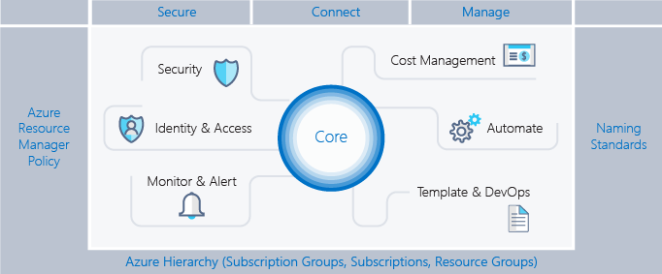

##### Audience

The document has been prepared for a technical audience, covering both architecture/engineering and operations. The assumption is that readers have a basic understanding of Azure.

The structure is such that SME (Subject Matter Experts) can read individual chapters, that are of interest to them.

* 1. Documentation Structure

This document is only one in a series of documents used to describe the overall Azure implementation.

##### Azure Functional Specification (this document)

Documents the foundational setup of Azure covering processes, architecture and design. It doesn’t address how individual Resource Types are deployed and used but focusses on the fabric into which these resources are deployed – the exception being the Resource Types required to build this foundation.

Based on this documentation the individual Subscriptions are configured along with resources for networking, monitoring (financial, security), automation etc. This setup can be performed manually via the portal of by developing IaC (Infastructure as Code) artifacts.



##### Service Specifications

Defines how individual Azure Resource types are operationalized. The assumption is that each Azure Resource type being used is not simply being deployed via the portal or arbitrary IaC artifacts. Instead Azure design patterns are defined and assessed from a process, financial, security, availability and performance point of view. The resulting document is approved by all involved parties and serves as the baseline for the development of the IaC artifact.

This can be thought of as AaaS (Azure as a Service), defining the consumable Azure Resource types and their characteristics. A Cosmos DB example:

* Table API model only – not other models supported
* Master keys stored in Azure Key Vault instance
* Scheduled key rotation using Azure Automation
* Firewalls configurable by Network team only
* Automatic backup – no custom backups
* Metrics/logs forwarded to central Log Analytics instance in Core Subscription
* Options provided for this design pattern:
  + DB Replication
  + VNET integration

While this is not a must, Service Specifications are ideally defined and implemented as Services in the ITIL Service Request portal (hence the name). This ensures a fully automated end-to-end solution.

##### Repository

A repository containing all IaC artifacts. These artifacts are developed based on the Functional Specification and the Service Specifications. Throughout the document below pictogram links to a corresponding IaC example on GitHub.

[](https://github.com/fbodmer/AzureGovernance/wiki/PAT0050)

##### Overall Design

A comprehensive overview of the foundational setup as well as all the design patterns documented in the individual Service Specifications. This illustrates how individual Resource Types are deployed into the foundational framework.



* 1. Foundation Setup and Portfolio Management

This chapter addresses at what point in time, in which context and sequence the artifacts outlined in the previous chapter are produced.

##### Foundation Setup

The Functional Specification is the starting point for deliverables in this phase. A set of Service Specifications might also be required – at least the one covering the deployment of Resource Groups. A Service Specification for the deployment of Subscriptions is only required if Subscriptions are orderable. Otherwise a manual setup based on the specifications in the Functional Specification might be sufficient.

The IaC artifacts for the deployment of the foundation are developed – based on the requirements in the Functional Specification. While the foundational setup might be performed manually it is advisable to automate as much as possibly, to ensure consistency and replicability.

The IaC artifacts for the Service Specifications are developed in parallel. As outlined above, at least one set of IaC artifacts for the Resource Group deployment is required.

In most cases the Core Subscription might be setup manually or partially automated as this is a one-off activity. The Standard Subscriptions and Special Subscriptions should be setup automated to ensure consistence.

At this point the ordering of Resource Groups could be published in the ITIL Service Request portal.

Azure offers around 100 different Resource Types, it is therefore not feasible to operationalize all of them. A triage activity needs to be institutionalized that selects and prioritizes Resource Type for operationalization. This might already be included in the foundation phase as limiting the service catalog to Resource Groups might be a bit sparse. In most cases it’s obvious which Resource Types to operationalize, simply by assessing what has already been deployed in Azure.



##### Service Development (on-going)

Once the foundational setup is complete an iterative, on-going process is initiated. Monitoring the Special Subscriptions (used for PoC by developers) will provide valuable insight as to what Resource Types are being used. Based on this list of Resource Types the next ones to be operationalized are selected. As before, operationalization includes authoring the Service Specification, developing the IaC artifacts and publishing in the Service Portal. A cost-benefit assessment needs to be performed to determine if the development of IaC artifacts is a sensible approach. For Resource Types that are rarely used, IaC development might not be feasible with deployment by Azure portal being preferable.

##### Service Maintenance (on-going)

Operationalized Resource Types need to be maintained and/or continually developed. There are several reasons for that:

* Announcements of new functionality by Microsoft
* Changes in requirements by development or operations
* Implementation of planned enhancements such as adding another model to a Cosmos DB pattern or adding a decommissioning service.
  1. Roles and Responsibilities

Based on the process outlined above the following roles and responsibilities are required:

Cloud Manager: While this might be perceived as an administrative role, the Cloud Manager requires a technical background. Technical understanding of the Resource Types is required to assess their financial, security and operational requirements. This will enable the Cloud Manager to understand incurred cost and the necessity of operationalizing additional Resource Types. An active portfolio management is based on understanding the functionality of individual Resource Types. This is applicable for financial and functional portfolio management. [Azure Reserved VM Instances](https://azure.microsoft.com/en-us/pricing/reserved-vm-instances/) have an impact on financials but are technical in nature. Understanding what Resource Types require operationalization next is possible only if the Cloud Manager can discuss Azure architectures with developers.

SME: Subject Matter Experts are responsible for sets of Azure Resource Types. Ideally this is an extension of the existing organization, e.g. the SQL Engineering team assumes ownership of the [Azure Database](https://azure.microsoft.com/en-us/product-categories/databases/) Resource Types. The Engineers are responsible for the development of the Service Specification as well as the IaC implementation. They are also tasked at monitoring the [Azure news feed for databases](https://azure.microsoft.com/en-us/blog/topics/database/).

Autom. Eng.: Automation Engineers are responsible for the setup and operation of the Automation Environment. They are also tasked with ensuring that overall IaC development standards are applied as well as the optimal use and re-use of the code base. Ideally the SME develop their own IaC (not the Automation Engineers) since this is the best approach to understanding a Resource Type in detail.

* 1. Architecture Review

An Architecture Review process needs to be established to ensure that deployments in Azure meet the established operational, financial and security requirements. This review is performed against the foundational architecture outlined in this document as well as the individual Service Specifications.

A first review coinciding with the infrastructure design phase and the start of the development aims at ensuring that the proposed architecture meets the established guidelines.

A second review, prior to the production start assesses the final product, involving the required Azure Resource Type as well as their connectivity.

In both review stages there might be no infrastructure topic to be addressed. This is the case when business applications use Azure Resource Types that are already operationalized.



* 1. Ordering Elements

With [Management Groups](https://docs.microsoft.com/en-us/azure/governance/management-groups/index), Subscriptions, [Resource Groups](https://docs.microsoft.com/en-us/azure/azure-resource-manager/), Tags and Resource Names there are five ordering elements available in Azure. Subscriptions are used to separate environments such as Development, Integration and Production, essentially mimicking the on-premise setup. Special purpose projects that are operating independently in the cloud, might also be configured in their own, dedicated Subscriptions.

Resource Groups are used within Subscriptions to group individual resources. Each Azure Resource must be deployed into a Resource Group. Resource Groups are differentiated into ones for business applications and for core services such as networking.

All Resource Groups and Resources are tagged. The tagging is used for operational and reporting purposes. Tags on Resource Group level can be re-used on Resource level. This can be accomplished by inheriting or duplicating the Resource Group Tags. Operational type Tags are likely replicated (written to Resource Group and Resource) as they need to be visible on the Resource level in the portal. Reporting type Tags are mostly inherited (derived from Resource Group) as they are used in reports.



The naming of individual resources should address all needs such as the use of names in the Azure portal, PowerShell code, CMDB, reports and dashboards. It’s important that the names are descriptive without the context of a Resource Group, Subscription or Tags.

Managements Groups are not per-se an ordering element but can be used to group like Subscriptions and have them inherit Policies and Access Control from the Management Group.

* 1. Agility vs. Control

When creating Resources in a Subscription, agility must be balanced with control. While users prefer complete freedom in creating and managing resources, certain supervision with regards to security, cost control and manageability must be implemented.

Balancing agility and control should be one of the main driver for the development of this Functional Specification.

1. [](https://github.com/fbodmer/AzureGovernance/wiki/SOL0001)Subscriptions
   1. Microsoft Azure Enterprise Portal

In the Microsoft [Azure Enterprise Portal](https://azureonboardingguide.blob.core.windows.net/gov/Microsoft%20Azure%20Government%20-%20Indirect%20EA%20Customer%20Onboarding%20Guide.pdf), a single hierarchy is configured consisting of one Enterprise, Department and Account each. All Subscriptions are attached to this single account – see next chapter for details on the Subscription model.



Decide if this structure in the EA is applicable.

For the following reasons implementing an Department/Account structure in the Enterprise Portal might be required – as opposed to the proposed 1:1:1:n relationship.

##### De-centralized Subscription Management

In cases where the Subscription management is not centralized, several Accounts and/or Departments might be required. This would allow for different Service Administrators to be responsible for a subset of Subscriptions each in the EA portal.

##### Billing

The billing for the Subscriptions is consolidated on Department level. Microsoft issues separate invoices for each Department. However, in most cases cost analysis and cross-charging is performed on Resource Group and/or Resource level. This is preferably performed by tagging the Resource Groups and Resources. If at all possibly the tagging for cross-charging purposes should be limited to the Resource Group level:

* Some Resources can’t be tagged
* Cross-charging on Resource level often leads to discussion about how to split cost on Resources that are used by multiple projects, e.g. SQL PaaS server operating multiple databases.
* Reconciliation with the invoice received by Microsoft might be complex as the different Resource Types would have to be mapped.

##### Service Administrator Inheritance

The Service Administrator configured on Department level is inherited by all Subscriptions attached to that Department. Each Resource Group and Resource hosted in that Subscription will in turn also inherit that Service Administrator as an Owner. For details refer to chapter *3 RBAC.*

* 1. Azure Subscription Model

Azure Subscriptions are implemented in a hub and spoke model. The individual Subscriptions are grouped into three different categories. Depending on the policy and IAM requirement the categories might be modelled as Management Groups (see chapter *5 Policies*).



Decision required if this is the Subscription model and naming to be implemented. Might need more Standard Subscriptions.

##### Infrastructure Subscriptions

These Subscriptions are used by the infrastructure teams and don’t host any business workloads.

###### Core Subscription

This basically resembles the setup of on-premise data centers, where core infrastructure services (DNS, backup, AD etc.) are operated by a core IT team. These core services are made available to the different environments that host the business-related workloads.

Likewise, there is a Core Subscription that hosts core services and is operated by the core infrastructure team. If possible, there are no business workload operated in this subscription. Some exceptions might have to be made for Azure Resource Types that can be instantiated once per customer, such as Azure Data Catalog.

###### Sandbox Subscription

The infrastructure team is performing Azure related PoC, development and testing in the Sandbox Subscription. Examples of activities are the operationalization of Azure Resource Types, development of Automation Runbooks, PoC of Resource Types to be introduced. All these activities are executed from an infrastructure point of view. The development teams preform their functional testing in a special Subscription. Example:

* The development team deploys Cosmos DB in a special Subscription to determine if this PaaS could be used in the context of a new business application to be developed.
* The infrastructure team will deploy Cosmos DB in the Sandbox to understand the security, financial and operational ramifications.

##### Standard Subscriptions

In addition to the Core Subscription there are three Standard Subscriptions for Development, Integration and Production. These are all operated by the core infrastructure team. Only operationalized Azure Resource Types are deployed into these Subscriptions. From a policy point of view a white-listing approach is used.

Access and deployment methods become ever more restrictive from Subscription to Subscription. In the Development Subscription, the developers are free to deploy Resources as they please, using service requests, Azure portal or the IDE (Integrated Development Environment).

In the Integration Subscription the deployment of Resources is in an automated manner only. This can be achieved by triggering the automation from a service requests or a CI/CD framework. This Subscription therefore is also used to test the integrated deployment of Azure resources and business applications.

The Production environment is accessibly by the operate teams only. Developers will only gain temporary access in trouble shooting situations.

##### Special Subscriptions

A differentiation must be made between criteria for placing a workload into a Special Subscriptions (as opposed to a standard Subscription) and creating a new special Subscription (as opposed to using an existing one).

The goal is to maintain as few Special Subscriptions as possible. Special Subscriptions that are created for a specific project should be time boxed, to prevent a multiplication of stale Subscriptions.

###### Placement Criteria

The following criteria must be met for placing a workload into a special Subscription:

* One or several of the required Resource Types are not available in the Development Subscription.
* Policies in the Development Subscription would have to be altered – but can’t for e.g. security reasons.
* The resources are used for a PoC or an exploratory project, but not for development.

###### Creation Criteria

* The resource requirements are such that the [Azure Subscription Limits and Quotas](https://docs.microsoft.com/en-us/azure/azure-subscription-service-limits) might be reached, impacting other workload in the Subscription.
* Subscriptions operated by third parties such as development partners or subsidiaries.

Are these Criteria applicable, anything missing?

* + 1. Resource Groups

In the Standard Subscriptions the environments are separated by Subscriptions, with the Resource Groups being used to separate applications or projects.

In the Special Subscriptions it is up to the Resource Group owner on how to group the Azure Resources. Most likely it is by project and possibly different prototypes or similar.



Decision required if this is the Resource Group model to be implemented.

##### Resource Group Location

The Resource Group location should be selected where most Resources are expected to be deployed, this could also be viewed as the operational location of the Resources.

The significance of a location on a Resource Group is only relevant for the storage of its metadata. Information such as Tags are store in the location where the Resource Group is hosted.

* 1. Subscription Naming Convention

Subscriptions are named as outlined in the diagram above. For Special Subscriptions a two-digit counter is used as the short-code.

* + 1. Supporting Tenants

The naming convention for the Subscriptions is adjusted to accommodate a tenant[1] model. This is required in situations where the resources in Azure need to be separated or combined, resulting e.g. from the sale or purchase of companies.

The Subscription name remains a combination of a free text and a short code. The short code is simply amended with a tenant number.

|  |  |  |
| --- | --- | --- |
| **Root Tenant** | **Tenant Ab -> ID 1** | **Tenant Xy -> ID 2** |
| **Standard Subscriptions** |  |  |
| Development-de | AbDevelopment-1de | XyDevelopment-2de |
| Integration-it | AbIntegration-1it | XyIntegration-2it |
| Production-pr | AbProduction-1pr | XyProduction-2pr |
| **Infrastructure Subscriptions** |  |  |
| Sandbox-sb | AbSandbox-1sb | XySandbox-2sb |
| Core-co | AbCore-1co | XyCore-2co |
| **Special Subscriptions** |  |  |
| Special-01 | AbSpecial-101 | XySpecial-201 |

This approach ensures that the Subscription short codes are used identical across tenants, making it easy to identify e.g. Development in each tenant. It also avoids adding another element to the Resource naming (see chapter *7 Naming Standards*).



Decision required if this is the naming convention to be implemented.

* 1. RBAC

For details refer to chapter *RBAC*

* 1. Policies

For details refer to chapter *Policies*

* 1. Quota Increase

In the Standard Subscriptions usage and quotas are monitored (see chapter ‘Monitoring and Alerting’). Quota increase requests are handled by the central IT Operations team.

The monitoring and increase of quotas for the special purpose Subscriptions is handled by the Subscription owners.

* 1. [](https://github.com/fbodmer/AzureGovernance/wiki/PAT2900)CMDB

In connection with Azure the significance of a CMDB is greatly reduced since a Subscription inherently offers a CMDB. Unlike in an on-premise environment there is no discovery required as all Resources in a Subscription can be queried using REST or PowerShell. This leaves the question on how to proceed with CMDB implementations, what CIs and CI relationships are used to represent Azure Resources, how they can be modeled and instantiated.

##### Discovery

While most CMDB vendors offer discovery functionality for Azure there are usually a couple pitfalls. The tools are not likely to discover all of the 100+ Resource Types. Even if they do, it is unlikely that they can keep their product up-to-date, due to the frequency of product announcements by Microsoft.

##### Modelling

When modelling Azure related CIs and CI relationships existing classes of the tool should be used whenever possible. If there are no corresponding classes generic classes are used with a ResoureType attribute or similar denoting the Azure Resource Type.

The relationships should be kept to a minimum such as the ones outlined in the BMC Atrium model below. Relationships between Resources, Resource Groups and Subscriptions need to be modelled. An optional Relationship is the one to an Environment class. This would not be required if Subscriptions represent environments.

Below model illustrates an option on how to model Azure Resources in the CMDB. One of the main questions to be addressed is the redundancies that are required:

* The environment can’t be derived from the Subscription, as Special Subscriptions might contain Resources that are hosted in different environments – Resource Groups could be used to separate environments.
* Collections could be listed as attributes on the individual CI, reducing the number of CI and Relationships. However, most of the collections will be used as List-Of-Values in the Service Request forms. Hence, using collections might be a sensible approach.



CIs are created only if required in the forms for Service Requests, e.g. list of available Resource Groups or for ITIL processes that must reference a CI – e.g. Change Process.

Decision required if and what CMDB CI models to be implemented.

* 1. Subscription Monitoring and Alerting

A differentiation must be made between security, availability, performance and financial monitoring.

* + 1. Security Monitoring

##### Out-of-Band Monitoring

The [Activities](https://docs.microsoft.com/en-us/azure/monitoring-and-diagnostics/monitoring-overview-activity-logs?toc=/azure/azure-monitor/toc.json) of the Core Subscription and the Standard Subscriptions are forwarded to a central Log Analytics instance in the Core Subscription. Activities of Special Subscriptions are forwarded on a case-by-case basis.

Based on this Activity information, out-of-band changes can be monitored. What constitutes an out-of-band change is defined in the Service Specification for the individual Resource Types. For Resource Types that are fully automated, any change not performed by the Automation user would be out-of-band. For other Resource Types only user belonging to specific AD Groups have the right to perform changes.



Decision required if the forwarding of the Activities is to be implemented, this also includes the location and naming of the Log Analytics instance.

* + 1. Availability and Performance Monitoring

##### Subscription Limits

In Azure, every Resource is deployed in an Azure Subscription. Each [Subscription has specific limits (or quotas)](https://docs.microsoft.com/en-us/azure/azure-subscription-service-limits) associated with it. Some of these limits are hard quotas that cannot be altered. Other limits, called soft quotas, are imposed but can be increased by contacting Microsoft Support.

Whenever a Subscription limit is reached, new resources using the Resource Type that has been depleted cannot be provisioned. For example, if the maximum number of cores in a specific region has been reached, no new Virtual Machines can be created in that region. This could potentially impact the entire environment, since at this point, (automatic) scaling of resources (for example adding Cluster Nodes to a Service Fabric Cluster), will fail.

Each Subscription quota or limit is either global; which means that the quota or limit is counted towards all the resources deployed globally in the Subscription, or regional; which means that the quota or limit applies only to a specific Azure Region (sometimes referred to as Data Center).

###### Implementation

An Azure Automation Runbook collects daily usage and quota data from the individual spoke Subscriptions and writes them into the Log Analytics instance in the Core Subscription.

A report is executed comparing used resources with available quotas. If a pre-defined threshold is reached an Alert is sent to all User/AD Groups listed as Owner on Subscription level. Optionally, consolidated dashboards for an overview of usage and quotas can be created - like what is available in the Azure Portal for individual Subscriptions.



Decision required if this is the monitoring to be implemented, this also includes the location and naming of the Log Analytics instance. Dashboard, Reports and Alerts need to be defined.

1. Naming Standards

These naming standards apply to all resources deployed in the Core and the Standard Subscriptions. For the Sandbox and Special Subscriptions, the naming standards for Resource Groups are enforced, the others are recommended.

Resources in the Standard Subscriptions are deployed automatically and therefore always comply with naming conventions. Resources in the Core Subscription and core resources in all other Subscriptions are deployed in a semi-automated fashion by IT infrastructure teams.

The deployment of Resource Groups into Special Subscriptions is automated. The naming of resources can’t be enforced but is encouraged to avoid potential issues when transferring into the Development Subscription.

The naming standard is defined on GitHub: <https://github.com/fbodmer/AzureGovernance/wiki/Naming-Convention>

Is Naming Standard as outlined in this chapter applied or are changes required?

1. Azure Active Directory
   1. O365 Tenant vs. Azure Active Directory Instance

It’s important to understand that Azure Active Directory is essentially a Microsoft Cloud directory that is managed out of the Azure portal but is not necessarily connected to Azure. Customers using O365 only or any other Microsoft cloud service have at least one Azure Active Directory instance. That directory is managed from the Azure Portal, even if the customer has no Azure Subscription.

In O365 documentation the term ‘tenant’ is referenced often but sometimes not used [correctly](https://docs.microsoft.com/en-us/office365/enterprise/subscriptions-licenses-accounts-and-tenants-for-microsoft-cloud-offerings) as it refers to an instance of Azure Active Directory - instead of regional location that houses the servers providing cloud services.

A customer can maintain multiple Azure Active Directory instances but only one of them can be connected to an Azure Subscription. How many instances are maintained should be based on the same logic that was applied on-premise. It is however suggested to maintain an instance for Active Directory related tests.



* 1. Domain Join to on-premise AD

The Azure Active Directory connected to an Azure Subscription is used for RBAC on all Resources operated in that Subscription. However, this doesn’t prevent Windows servers operated in that Subscription to be joined to an on-premise AD. It’s important to differentiate between controlling the VM via the Azure portal and access to the OS.

[Azure Active Directory Domain Services](https://docs.microsoft.com/en-us/azure/active-directory-domain-services/active-directory-ds-overview) was not thought as a replacement for on-premise Domain Controllers (DC). A migration would have to be thoroughly planned. However, for most customers this is not a feasible approach as most workloads are running on-premise, particularly client computers.

Will VMs be domain joined on-premise?

* 1. Azure Active Directory instances used

The Enterprise Portal as well as the individual Subscriptions are all connected to the Azure Active Directory customer.onmicrosoft.com. That Azure Active Directory is synchronized with the on-premise Active Directory using Federation Services.



An additional Azure Active Directory might be instantiated for Active Directory related tests, but this is a completely standalone instance.

##### AD Users and Groups – MACD

The existing IAM processes remain in place and are used to the create AD Users and Groups required in Azure Active Directory. User and groups are not configured directly in Azure Active Directory.

Is this correct with regards to FS and optional dedicated AAD for Special Subscriptions.

* 1. Additional AAD Instances

Optionally and upon approval by the security department, special purpose Subscriptions can be connected to a dedicated Azure Active Directory. This Azure Active Directory could also be configured in a B2B scenario as outlined below.



* 1. AAD Monitoring and Alerting

The Audit and Sign-in logs of all AAD instances are forwarded to the security Log Analytics instance in the Core Subscription.



Decision required if this is the monitoring to be implemented, this also includes the location and naming of the Log Analytics instance. Dashboard, Reports and Alerts need to be defined.

1. RBAC

RBAC must be addressed in the context of all layers, from the Enterprise Portal all the way down to an individual Resource.

* 1. Inheritance

It’s important to note, that access control in Azure is based on inheritance starting at the Enterprise Portal level and extending to individual Resources. A common model is outlined below.



##### Service Administrator

The Service Administrator of a Subscription is inherited from the Enterprise Portal and is therefore the same for all Subscriptions. This applies to the Standard Subscriptions as well as to the special purpose ones. This inherited user is configured with an *Owner* role.

The Service Administrator and Co-administrator (see below) are used for Subscription level changes only and not for day-to-day usage.

The Service Administrator can be an actual user or a technical user. It’s also possibly to configure multiple Service Administrators as well as replacing existing Service Administrators.

##### Co-administrator

In the Infrastructure Subscriptions and Standard Subscriptions, a Co-administrator with an Owner role is configured to cover absences of the Service Administrator, e.g. due to vacation.

In the Special Subscriptions, a single/multiple AAD user/s will be assigned the *Owner* role with co-administrator credentials. It is then up to these users to configure all other users.

Need to define who is defined as Service Administrator and Co-administrator.

##### Automation

An Automation user is defined with an Owner role on Subscription level. This is a technical user required by the automation framework. This ensures that automated tasks can be performed on all resources in a Subscription.

Need to define the name of the technical Automation account

##### Operations

Different operations teams are assigned roles on Subscription level. As an example, the authority to change the firewall on a Cosmos DB instance is assigned to an AD Group consisting of security specialists. Because this definition is implemented at Subscription level it is applicable to all Cosmos DB instance in the Subscription.

The definition of what RBAC must be assigned on Subscription level is defined in the following chapters as well as the Service Specification for the individual Resource Types.

##### Read-only Group

All users that have access to Azure (MACD of resources) are added to a read-only group on the Core and all Standard Subscriptions. This does not apply to users that only have front access to resources hosted in Azure, e.g. via a connection string to SQL PaaS.

Is a Read-only role used, what is it called.

##### Groups and Users

AD Groups and AD Users can be assigned to roles on any Resource Group or Resource. The following chapters outline how this is defined for each Resource in the Core Subscription. The Service Specification Documents define the access control for the individual Azure Resource Types.



##### EA Portal

In the EA Portal there are two user types configured. Read users that have access to all Departments, Accounts and Subscriptions. These users are actual individuals available in the AAD connected to the EA portal.

A single technical user is created that has full access to the EA portal, including the rights to add, change and delete Subscriptions. This is a technical, non-personal users available in the AAD connected to the EA portal. This user is configured with a split password, meaning several individuals have access to a portion of the password. Only by combining the password fractions of all users is a login possible. This approach ensure that no single user can delete a Subscription.

##### Subscription

* 1. Deny Assignment – Preventing Inheritance

As outlined in below diagram the Cosmos DB instance has RBAC assigned by inheritance from the Enterprise Portal, the Subscription and the Resource Group. Another two RBAC are defined on Resource Level. One for the Developers using the Contributor role and another for Security with a role to manage the Cosmos DB firewalls.

For all users with a Contributor or Owner role a [Deny Assignment](https://docs.microsoft.com/en-us/azure/role-based-access-control/deny-assignments) is required that prevents them from performing firewall changes on the Cosmos DB instance. The definition of this Deny Assignments essentially prevents the inheritance from higher levels. Another advantage is that built-in roles can be customized, preventing the creation of custom roles. As with the RBAC, the Deny Assignments are defined in the Service Specification for the individual Resource Types.

The definition of what Deny Assignments must be configured on Subscription level is defined in the following chapters as well as the Service Specification for the individual Resource Types.



Ideally a Deny Assignment is configured for each Service Administrator and Co-administrator, limiting their access to Subscription type tasks, but no access to Resource Groups and Resources.

* 1. Privileged Identity Management

[Privileged Identity Management](https://docs.microsoft.com/en-us/azure/active-directory/privileged-identity-management/) allows for temporary access to be provided to a specific AD group or User. In a production environment the Owner role is assigned to the technical automation user only. If other users need temporary access this is implemented by use of a Service Request configuring the required temporary access using Privileged Identity Management.

This is only required in very advanced implementations where access is tightly controlled. In these circumstances the implementation of a Service Request is required.

* 1. Mapping of



1. Policies
   1. Policy Levels

[Policies](https://docs.microsoft.com/en-us/azure/governance/policy/overview) can be defined on [Management Group](https://docs.microsoft.com/en-us/azure/governance/management-groups/index), Subscription or Resource Group level. Below diagrams illustrates the Subscription design from a Management Group point of view. The assignment of Policies needs to be coordinated across all three levels. Assignment on higher levels might have an unwanted impact on lower levels. A Management Group Policy limiting Resource deployments to Europe would essentially prevent the use of Resources that are [not available in Europe](https://azure.microsoft.com/en-us/regions/offers/). A possible solution might be a combination of Policies such as preventing deployment to Regions that are not used under any circumstances on Management Group level and on Resource Group level define project specific limits.



* 1. Policy Definition Process

In a first step the policies for the individual Subscriptions are defined using below table. Where as the definitions for the Special Subscriptions are default values, that need to be adjusted at deployment time.

Once the individual Policies are defined they can be assessed as to the feasibility of moving some of them into a Management Group structure and the use of [Initiative Definitions](https://docs.microsoft.com/en-us/azure/governance/policy/overview#initiative-definition) – collection of policy definitions used to achieve a singular overarching goal.

For the technical implementation Policy Name, Display Name and ID are configured using identical values.

|  |  |  |  |  |  |
| --- | --- | --- | --- | --- | --- |
| Policy Name | Sandbox | Development | Integration | Production | Special |
| Allowed locations | All | WEU/NEU | WEU/NEU | WEU/NEU | All |
| Allowed resource types | All | Operationalized | Operationalized | Operationalized | - |
| Allowed storage account SKUs |  |  |  |  |  |
| Allowed virtual machine SKUs |  |  |  |  |  |
| Apply tag and default value[2] | - | - | - | - | - |
| Enforce tag and value | - | - | - | - | - |
| Not allowed resource types | - | - | - | - | Which not |
| Require SQL Server version 12.0 |  |  |  |  |  |
| Require storage account encryption | Yes | Yes | Yes | Yes | Yes |
| …. |  |  |  |  |  |

Need to complete above table and define possibly Management Group level and Resource Group level policies.

1. Tagging

Below tagging is applied to all Resource Groups and Resources.

* 1. Resource Groups

The *Budget* Tag might not be required as this value is configured in the Cost Management Budget (see chapter *11.2.1 Budgets and Alerting*). A more elaborate approach that also handles temporal issues (Tags changing) with the Tags is addressed in chapter *11.3 Cost Allocation*.

|  |  |  |  |
| --- | --- | --- | --- |
| Name | Values | Source | Remarks |
| ApplicationId | Application-ID | Service Request | ID of the application, retrieved from the application inventory |
| CostCenter | SAP Cost Center No. | Service Request | SAP Cost Center to which the incurred expenses are cross charged |
| Budget | CHF | Service Request | Expected monthly cost for all Resources in the Resource Group |
| Contact | marc.keller@domain.com | Service Request | E-mail address of the person or group responsible for the Resources in the Resource Group. A distinction might be required between financial responsibility and operational responsibility. |
| Automation | Version number | Automation | Version of the Runbooks used for the creation of the Resource Group |
| <operational> | Free text | Manual | Operational teams are free to capture additional Tags, required for operational purposes |

Need to finalize above table.

* 1. Resources

By default, the Tags of the Resource Groups are not written to the Resources in the Resource Group. Resource Group Tags are only written to Resources if they contain different values from the one on Resource Group level.

Tags required for an automated shutdown of resources such as SQL PaaS are not added at this time. They will be added if the actual automation for these types of shutdowns are implemented.

|  |  |  |  |  |  |
| --- | --- | --- | --- | --- | --- |
| Name | | Example | Source | | Remarks |
| <Tags defined on Resource Group level, that differ on individual Resources> | | | | | |
| Responsible | marc.keller@domain.com | | Service Request | E-mail address of the person or group responsible for the Resources in the Resource Group. A distinction might be required between financial responsibility and operational responsibility. | | |
| Automation | Version number | | Automation | Version of the Runbooks used for the creation of the Resource Group | | |
| <operational> | Free text | | Manual | Operational teams are free to capture additional Tags, required for operational purposes | | |

Need to finalize above table and agree to not replicate tags.

* 1. Tag Management

Tags must be actively managed to ensure they are up to date and consistent with data in other Resources and systems. This is ideally performed with a set of Azure Automation Runbooks.

##### Missing Tags

Some Resource Groups are automatically created as an integral part of a Resource Type deployment. Periodically theses Resource Groups need to be identified and properly tagged.

##### Stale Tags

Tags might be stale because e.g. Cost Center numbers have been changed or re-assigned. For this reason, Tags must be changeable on a large scale.

##### Alignment with Budget

The same values as in the *Budget* and *Verantwortlich* Tag are used in the Cost Management Budget functionality. Possible discrepancies between the values in the Tag and in Cost Management should be determined periodically.

Need to define which Tag Management Runbooks are required. Check chapter *11.3 Cost Allocation* for additional details.

1. Networking

Below diagram depicts the network design covering both the Core and Standard Subscriptions – Development is used as an example. The design for the Special Subscriptions must be defined case-by-case.

Firewalls are not shown, please refer to the respective sub-chapter for details.



* 1. [](https://github.com/fbodmer/AzureGovernance/wiki/PAT0050)VNET – Virtual Network

Each Standard Subscription is configured with a single [VNET](https://docs.microsoft.com/en-us/azure/virtual-network/), that is divided into a frontend, backend and management Subnet. While the configuration of multiple, non-continuous address spaces is supported it is preferable to use a single, continuous address space for a VNET. The size of the address space depends on what is hosted in the VNET. PaaS Resources require only limited addresses, unlike IaaS that requires an address per instance.



* + 1. Subnets

At a minimum a /24 range is assigned to the VNETs. That range is subdivided into a /25 range for the frontend Subnet, a /26 for the backend subnet and a /28 for the management Subnet. The reminder is reserved for special purpose Subnets that are required by certain Resource Types, such a VPN Gateways or Firewalls.

|  |  |  |  |  |  |  |  |  |
| --- | --- | --- | --- | --- | --- | --- | --- | --- |
| Regions | Core | | Sandbox | | Development | | Production | |
| WEU | weu-co-vnt-01 | 10.22.0.0/22 | weu-sb-vnt-01 | 10.22.32.0/22 | weu-de-vnt-01 | 10.22.64.0/22 | weu-pr-vnt-01 | 10.22.96.0/22 |
| NEU | neu-co-vnt-01 | 10.22.4.0/22 | neu-sb-vnt-01 | 10.22.36.0/22 | neu-de-vnt-01 | 10.22.68.0/22 | neu-pr-vnt-01 | 10.22.100.0/22 |
| WUS | wus-co-vnt-01 | 10.22.8.0/22 | wus-sb-vnt-01 | 10.22.40.0/22 | wus-de-vnt-01 | 10.22.72.0/22 | wus-pr-vnt-01 | 10.22.104.0/22 |
| EUS | eus-co-vnt-01 | 10.22.12.0/22 | eus-sb-vnt-01 | 10.22.44.0/22 | eus-de-vnt-01 | 10.22.76.0/22 | eus-pr-vnt-01 | 10.22.108.0/22 |
| SEA | sea-co-vnt-01 | 10.22.16.0/22 | sea-sb-vnt-01 | 10.22.48.0/22 | sea-de-vnt-01 | 10.22.80.0/22 | sea-pr-vnt-01 | 10.22.112.0/22 |
| EAS | eas-co-vnt-01 | 10.22.20.0/22 | eas-sb-vnt-01 | 10.22.52.0/22 | eas-de-vnt-01 | 10.22.84.0/22 | eas-pr-vnt-01 | 10.22.116.0/22 |
| SA1 | sa1-co-vnt-01 | 10.22.24.0/22 | sa1-sb-vnt-01 | 10.22.56.0/22 | sa1-de-vnt-01 | 10.22.88.0/22 | sa1-pr-vnt-01 | 10.22.120.0/22 |
| SA2 | sa1-co-vnt-01 | 10.22.28.0/22 | sa1-sb-vnt-01 | 10.22.60.0/22 | sa1-de-vnt-01 | 10.22.92.0/22 | sa1-pr-vnt-01 | 10.22.124.0/22 |
|  |  |  |  |  |  |  |  |  |
| Total Azure | 10.22.0.0/16 | 65536 |  | Subnets: | xxx-xx-sub-vnt01-fe | /24 | 256 |  |
| VNET | /22 | 1024 |  |  | xxx-xx-sub-vnt01-be | /24 | 256 |  |
| Subnet | /24 | 256 |  |  | others |  | 512 |  |
| Total all VNETs |  | 32768 |  |  |  |  |  |  |

* + 1. Multi Region Deployment

A VNET is tied to a single Subscription and Region, for that reason a VNET is deployed to each Region that is supported in a Subscription. All VNETs are deployed to the same Resource Group and are configured identical, including the components not shown in below diagram but addressed in the following chapters.

This might be a good example for the use of Region ‘aaa’ in the Resource Group name. Resources in this Resource Group are deployed to multiple Regions and there is no region that could be defined as the operational center for the Resources.



Define the VNETs and address spaces. Potentially additional VNETs are required based on the supported communication patterns – see below. Need to also decide on the Region short code used in the Resource Group name.

* + 1. Connectivity between VNETs

Connectivity between VNETs is implemented by use of [VNET Peering](https://docs.microsoft.com/en-us/azure/virtual-network/virtual-network-peering-overview), both for communication between Subscriptions and Regions. Communication between Subscriptions must always involve the Core Subscription, there is no direct communication between e.g. the Production and Development Subscriptions. All traffic is to be routed via the Core Subscription.

The default VNETs in the Standard Subscriptions are peered to the Core Subscription. The Special Subscriptions are only peered in exceptional circumstances and after previous review.

The VNET Peering is configured for the non-Core VNETs to be able to use the VPN Gateway in the Core Subscription, for access to on-premise resources (see chapter below).



While there is no cost for VNETs, there is a nominal [charge incurred](https://azure.microsoft.com/en-us/pricing/details/virtual-network/) for VNET Peering.

Using Site-to-Site VPN is not really an option to VNET peering.

* 1. Jump Hosts

There are several options on how to implement Jump Hosts for servers operated in Azure. The two deciding factors are the location of the Jump Hosts and the available connectivity between on-premise and Azure.

If there is no VPN connectivity to Azure, the Jump Hosts should be in Azure as this is the only possibility to prevent an assignment of public IP addresses to all servers.

With VPN connectivity in place the communication to the Standard Subscriptions (and other peered Subscriptions) is always via Core Subscription. Irrespective of the location of the Jump Hosts.



The selected Jump Host design depends on the connectivity to on-premise – with/without VPN. If there is VPN connectivity then there are two options otherwise there are not options.

* + 1. Jump Host in Core Subscription via VPN and VNET Peering

In this scenario the Jump Host is in the Core Subscription which is connected to on-premise using S2S VPN.

Access to targets in Standard Subscriptions or Special Subscriptions that are peered with the Core Subscription.

* The Jump Host is located in the Management Subnet
* Access to the Jump Host is via S2S VPN, there is no public IP configured on the Jump Host
* The Jump Host is protected by the NSG configured on the Management Subnet
* Access to targets in the Core Subscription is by enabling communication from the Management Subnet to all other Subnets in NSG.
* Access to targets in different Subscriptions is via VNET Peering and configurations of the NSG in the target Subnets.



* + 1. Jump Host in Core Subscription via Internet and VNET Peering

In this scenario the Jump Host is in the Core Subscription but there is no S2S VPN from on-premise to the Core Subscription. Using an on-premise Jump Host is not feasible in this scenario as all the VMs in Azure would require a public IP address configured.

Access to targets in Standard Subscriptions or Special Subscriptions that are peered with the Core Subscription.

* The Jump Host is located in the Management Subnet
* Access to the Jump Host is via a public IP configured on the Jump Host
* The Jump Host is protected by the NSG configured on the Management Subnet
* Access to targets is via the private IP of the Jump Host
* Access to targets in Core Subscription -> see previous scenario
* Access to targets in different Subscriptions -> see previous scenario



* + 1. Jump Host on-Premise via VPN and Peering

In this scenario the Jump host is on-premise.

Access to targets via S2S VPN and VNET Peering for Standard Subscriptions or Special Subscriptions.

* Access to targets in Core Subscription is via S2S VPN
* Access to targets in different Subscriptions via S2S VPN and VNET Peering



* + 1. Special Subscriptions

This scenario is for Special Subscriptions that are not VNET peered with the Core Subscription. The Jump Host is located in the Special Subscription. This is a requirement as this is the only approach preventing all VMs from requiring public IP addresses.

Access to targets is within the VNET, with the Subnets protected by NSGs.



* + 1. Azure Jump Host Architecture

##### Windows Server Remote Desktop Services

There is a [market place offering](https://azuremarketplace.microsoft.com/en-us/marketplace/apps/rds.remote-desktop-services-basic-deployment) that deploys a RDmi (Remote Desktop modern infrastructure) environment. Different Azure based [reference architectures](https://docs.microsoft.com/en-us/windows-server/remote/remote-desktop-services/desktop-hosting-logical-architecture) are also available.

Similar offerings are also available as virtual appliances from vendors such as Citrix.

##### Windows Virtual Desktop

The announced [Windows Virtual Desktop](https://azure.microsoft.com/en-us/services/virtual-desktop/) offering is offering a Windows 10 multi-user environment. It is assumed that Windows Virtual Desktop will be operating on top of Windows Server Remote Desktop Services or similar partner offering.

From a licensing point of view this solution might not be cost efficient for the implementation of Jump Hosts. More will be known once Windows Virtual Desktop has been released.

##### Windows Server with Remote Desktop Sessions

Another alternative is to operate a Windows Server that serves as a Jump Host offering Remote Desktop sessions. This is the simplest setup as it only requires a standard Windows Server deployment with the Remote Desktop Session Host installed.

Need to define which Jump Host architecture to implement – if an additional implementation is required.

* 1. On-Premise Connectivity
     1. Site-to-Site VPN

Connectivity to on-premise data center(s) is implemented by use of VPN. At this point in time there is no justification for the deployment of ExpressRoute (see following chapter). At a later point in time ExpressRoute could be added to or replace VPN – if the need arises. There is no disadvantage to starting out using VPN.

VPN Gateways are implemented in the Core Subscription only. All other Subscriptions requiring access to on-premise resources need to use the VPN Gateway in the Core Subscription – via VNET Peering.

VPN Gateways are deployed redundant in an [active-active](https://docs.microsoft.com/en-us/azure/vpn-gateway/vpn-gateway-highlyavailable#dual-redundancy-active-active-vpn-gateways-for-both-azure-and-on-premises-networks) configuration and into different [Availability Zones](https://docs.microsoft.com/en-us/azure/vpn-gateway/vpn-gateway-highlyavailable).



* + 1. ExpressRoute

Express Route allows to access PaaS in Azure via L2 connectivity from on-premise data centers. The *Microsoft Peering* integrates all of Microsoft Cloud Services as well as all Azure public PaaS. It is important to understand that no differentiation is made between PaaS in a customer’s own Subscription and PaaS in other customers Subscriptions.

Instead of accessing PaaS over the internet, access from on-premise is via ExpressRoute. The concepts with regards to PaaS firewalls and PaaS authentication as outlined above still apply unchanged.

*Private Peering* integrates VNETs in an Azure Subscription with on-premise resources. This is essentially the same setup as S2S VPN with the exception that traffic doesn’t traverse the internet.



A redundant pair of routes is deployed in an ExpressRoute peering location. This is where the handover from the partners network to the Microsoft network takes place. The configuration of ExpressRoute is performed in one of the customers Subscriptions. That configuration can be used to connect to any VNET, no matter in what Subscription they are hosted. However, ExpressRoute premium is required to connect VNETs in different geographical regions, e.g. ExpressRoute in Europe to VNET in US West.

ExpressRoute can be combined with S2S VPN to create redundant connectivity.



* + 1. S2S VPN vs. ExpressRoute

Below topics list the advantages and disadvantages of using VPN vs. ExpressRoute.

##### SLA

Both VPN and ER require the deployment of a [VPN gateway, which supports an SLA of 99.9% or 99.95%](https://na01.safelinks.protection.outlook.com/?url=https%3A%2F%2Fazure.microsoft.com%2Fen-us%2Fsupport%2Flegal%2Fsla%2Fvpn-gateway%2Fv1_3%2F&data=02%7C01%7Cv-febodm%40microsoft.com%7Cd3712a7a3f8042ed6b3408d568ab2479%7Cee3303d7fb734b0c8589bcd847f1c277%7C1%7C0%7C636530006632471878&sdata=I0VGWeCnl03vJw%2BRzo68vq%2BjN5kCm1gj9PonG5jYgsk%3D&reserved=0) depending on the SKU. In case of VPN connections there is no additional SLA as the components (network, remote gateway) are not operated by Microsoft. For ER there is a [99.95% dedicated circuit availability SLA](https://na01.safelinks.protection.outlook.com/?url=https%3A%2F%2Fazure.microsoft.com%2Fen-us%2Fsupport%2Flegal%2Fsla%2Fexpressroute%2Fv1_3%2F&data=02%7C01%7Cv-febodm%40microsoft.com%7Cd3712a7a3f8042ed6b3408d568ab2479%7Cee3303d7fb734b0c8589bcd847f1c277%7C1%7C0%7C636530006632471878&sdata=IUInPF3ZYfplkbqKn%2BZvt9nw1HcDZwyfoJnd4gm0mds%3D&reserved=0).   
The release of [active-active site-to-site VPN connections](https://docs.microsoft.com/en-us/azure/vpn-gateway/vpn-gateway-highlyavailable) increased the availability of VPN links.

##### Bandwidth

[VPN offers bandwidth of up to 1.25 Gbps](https://na01.safelinks.protection.outlook.com/?url=https%3A%2F%2Fazure.microsoft.com%2Fen-us%2Fpricing%2Fdetails%2Fvpn-gateway%2F&data=02%7C01%7Cv-febodm%40microsoft.com%7Cd3712a7a3f8042ed6b3408d568ab2479%7Cee3303d7fb734b0c8589bcd847f1c277%7C1%7C0%7C636530006632471878&sdata=p9LfJfCSI5mTEsSuoj%2BrWHrSBrn3J0iK6WDkuIS3CSk%3D&reserved=0) while [ER offers speeds of up to 10 Gbps](https://docs.microsoft.com/en-us/azure/expressroute/expressroute-introduction#bandwidth-options) .

##### Link quality

From a technical point of view, one could argue that the link quality using ER is superior to VPN. However, VPN are an established technology, widely used by customers. Based on their experience with existing VPN, customers know best about the expected VPN link quality.

##### Latency

From a technology point of view ER offers better and more consistent latency than VPN. While the consistency of the latency is likely better with ER, the latency depends on the network architecture. With VPN, more fine-grained connectivity to Azure might be achieved, which also has an impact on latency. In any case, the latency is likely more dependent on the geographical location of the user community than the choice between ER and VPN.

##### Setup

The setup of ER is considerably more complex than the setup of VPN. One of the main reasons for the added complexity is the requirement to involve third parties in the setup process. While the provisioning of a VPN can be achieved in hours, days or weeks are required for ER.

##### Manageability

In a VPN environment, operational issues can be handled by customers. With ER the involvement of Microsoft and possibly a third-party carrier is required. In a worst-case scenario, a new/additional VPN can be provisioned, this is not possible using ER.   
Using ER, customers are dependent on the BGP routes published by Microsoft. Changes in these published routes (as happened before) can have an impact on established routing patterns. There is little or no control as to what BGP routes are announced by Microsoft.

##### Encryption & Traffic routing

While VPN can be natively encrypted, this is not an option on ER. On the other hand, ER is using dedicated links and is not traversing the internet as is the case with VPN. As all traffic to and from Azure should be encrypted, this is neither an advantage or disadvantage for either technology.

##### Pricing

Both VPN and ER require the deployment of a [VPN Gateway which is priced by hour of operation](https://na01.safelinks.protection.outlook.com/?url=https%3A%2F%2Fazure.microsoft.com%2Fen-us%2Fpricing%2Fdetails%2Fvpn-gateway%2F&data=02%7C01%7Cv-febodm%40microsoft.com%7Cd3712a7a3f8042ed6b3408d568ab2479%7Cee3303d7fb734b0c8589bcd847f1c277%7C1%7C0%7C636530006632471878&sdata=p9LfJfCSI5mTEsSuoj%2BrWHrSBrn3J0iK6WDkuIS3CSk%3D&reserved=0). In addition, ER offers a [metered or unlimited data plan](https://na01.safelinks.protection.outlook.com/?url=https%3A%2F%2Fazure.microsoft.com%2Fen-us%2Fpricing%2Fdetails%2Fexpressroute%2F&data=02%7C01%7Cv-febodm%40microsoft.com%7Cd3712a7a3f8042ed6b3408d568ab2479%7Cee3303d7fb734b0c8589bcd847f1c277%7C1%7C0%7C636530006632471878&sdata=rotacFk30SoLS9BPFQKygJvdWdN5uj5HNbnUVjsifQ4%3D&reserved=0), with an optional ER Premium add-on. This add-on raises some technical limits but most important allows for global connectivity. This means an ER circuit created in one Azure Region can be used in any other Azure Region. The benefits of ER Premium needs to be weighed against the used of VNET Peering (see below).

##### Connectivity options

There are multiple options on how to implement connectivity between VNETs in Azure and to on-premise data centers. VNET Peering within and across Azure regions can be combined with VPN and ER connections. One distinct advantage of ER is the possibility of using the Microsoft network as a backbone for intra/inter regional traffic. This option is available for any type of traffic pattern – Azure internal, on-premise internal, between Azure and on-premise.

##### Dependency on Subscriptions, AD Tenants and enrollment

VPNs are configurable in a single subscription for a single VNET only. ER on the other hand can span Subscriptions, AD Tenants and EA enrollment boundaries. In other words, a single ER link can be attached to any VNET independent of the location of the VNET with regards to Subscription, AD Tenant and EA enrollment.

##### IaaS vs. PaaS

VPN based connectivity is limited to VNETs and with that IaaS, with the exception of (the few) PaaS that can be configured using [Virtual Network integration](https://na01.safelinks.protection.outlook.com/?url=https%3A%2F%2Fdocs.microsoft.com%2Fen-us%2Fazure%2Fvirtual-network%2Fvirtual-network-for-azure-services&data=02%7C01%7Cv-febodm%40microsoft.com%7Cd3712a7a3f8042ed6b3408d568ab2479%7Cee3303d7fb734b0c8589bcd847f1c277%7C1%7C0%7C636530006632471878&sdata=8wHQbPOicEnQHMlqzvEKTP4DKPbKeXg86x16F%2FKclTg%3D&reserved=0). ER route offers connectivity not only to VNETs [(Private Peering) but also to PaaS and other Microsoft Cloud services (Microsoft Peering)](https://na01.safelinks.protection.outlook.com/?url=https%3A%2F%2Fdocs.microsoft.com%2Fen-us%2Fazure%2Fexpressroute%2Fexpressroute-circuit-peerings&data=02%7C01%7Cv-febodm%40microsoft.com%7Cd3712a7a3f8042ed6b3408d568ab2479%7Cee3303d7fb734b0c8589bcd847f1c277%7C1%7C0%7C636530006632471878&sdata=ybXvwxuKVKKk5mWulovUJBElCKb66PCW30lrpS0a2aY%3D&reserved=0). The advantage of ER is that PaaS services can be access via a private link and never traverse the internet – advantages/disadvantages with regards to latency, cost etc. are outlined above.

##### Traffic Shaping

ER offers QoS on Microsoft Peering for Skype Voice calls, no other QoS is available for ER. There is not QoS on VPN connections. Any traffic shaping and/or cost distribution needs to be implemented using third party virtual appliances.

Need to define the type of on-premise connectivity and the how to implement it – single, active/active

* 1. [](https://github.com/fbodmer/AzureGovernance/wiki/PAT0056)Network Security Groups (NSG)

For each Subnet a [NSG](https://docs.microsoft.com/en-us/azure/virtual-network/security-overview) (Access Control List) is configured – this is not applicable for technical transfer Subnets such as GatewaySubnets that don’t support (and don’t required) NSGs. NSG are used in conjunction with firewalls, they can’t be used instead of firewalls. Likewise, using firewalls without NSG is not advisable as some of the [Service Tag](https://docs.microsoft.com/en-us/azure/virtual-network/security-overview#service-tags) based rules can’t be implemented by use of firewalls. 

The NetworkSecurityGroupEvent and NetworkSecurityGroupRuleCounter of all NSG are forwarded to the Security Log Analytics instance in the Core Subscription. This is to provide a single point of data collection, reporting and alerting for security related topics.

* + 1. Communication Matrix

Below communication matrix defines connections between the individual subnets, environments and locations. The matrix serves as the baseline for the configuration of the NSGs and firewalls.



* Internet based traffic is differentiated in authenticated and non-authenticated traffic and is directed to UT and ST.
  + AT: Users are authenticated by an authentication provider such as AAD or Facebook  
     The client IP address is known
  + NA: Neither an authentication is performed, nor a client IP address known
* The firewall in the Core Subscription has an interface in each subnet
* The first dot in a line denotes the source of the session setup
* The arrow denotes the destination
* Intermediary dots denote the network interface on which the firewall is entered and left
* Bi-directional arrow for session establishment form both sides
* The internet and on-Premise communication is also applicable for the Core Subscription, in that case the second hop (to the non-Core Subscription) is not being performed.
* Communication channels not explicitly listed are not open by default, notable are:
  + Communication to on-Premise limited to/from FT/HT
  + No communication between Subscriptions with exception of FT/HT to Core
  + Communication within Subscription limited from HT to FT
* The design supports the by-passing of ST – UT directly to HT

Complete this communication matrix and adjust to requirements based on the following chapters.

* + 1. [](https://github.com/fbodmer/AzureGovernance/wiki/PAT0058)Configuration Table

Below configuration table is the translation of the communication matrix into actual NSG rules. For security reasons the NSG rules are not maintained directly in Azure using the Azure Portal. The rules defined in this table are applied using an Azure Automation Runbook. This automated approach reduces the risk for misconfiguration, resulting in security breaches. It also allows for the application of Rule Sets and the use of placeholders. Both are helpful if the same NSG rules need to be applied to multiple Subscriptions. The Rule Sets allow for a definition of which rules need to be applied in a particular scenario. Example:

* *Default* rules are always applied
* *SuToSu (SubscriptionToSubscription)* rules are applied for Subscriptions that communicate with other Subscriptions but are not applied for isolated Special Subscriptions.

The placeholders allow for the dynamic configuration of the rules once they are applied. This is required as e.g. the Backend Subnet address range is different in the individual Subscriptions. Using placeholders greatly reduces the number of different rules that need to be maintained.

|  |  |  |  |  |  |  |  |  |  |  |
| --- | --- | --- | --- | --- | --- | --- | --- | --- | --- | --- |
| RuleSet | Name | Description | Protocol | SourcePortRange | SourceAddressPrefix | DestinationPortRange | DestinationAddressPrefix | Access | Priority | Direction |
| Default | DenyBackendInbound-01 | Deny traffic from Backend | * | * | * | * | $BackendSubnetAddressPrefix | Deny | 123 | Inbound |
| Default | DenyAllInternetInbound-01 | Block access from the internet | * | * | * | * | Internet | Deny | 125 | Inbound |
| SuToSu | DenyBackendInbound-01 | Deny traffic from Backend | * | * | * | * | $BackendSubnetAddressPrefix | Deny | 123 | Inbound |
| SuToSu | DenyAllInternetInbound-01 | Block access from the internet | * | * | * | * | Internet | Deny | 125 | Inbound |

Complete this table and decide on how to implement it – using a CSV or an existing tool such as Tufin.

* 1. Traffic Patterns

It is important to understand that there are two fundamentally different methods in enabling communication with Azure PaaS and IaaS Resources.

*Internet based* communication is using the public facing interfaces of Azure PaaS and IaaS Resources. Traffic always traverses the internet, independent of the location of the source and target components.

*Azure VNET based* communication allows for the integration of PaaS, IaaS and on-premise Resources into a VNET. Traffic is only within the VNET and never traverses the public internet.



* + 1. Traffic Patterns without VNET

Deployments that don’t use a VNET can only be secured by the firewalls on the PaaS instance or authentication using providers such as AAD or Facebook. The firewalls offered by individual PaaS Resources is IP and protocol based, there is no WAF functionality provided. To implement a WAF an Application Gateway or virtual appliance from the marketplace is to be deployed.

From a technical point of view a distinction must be made between traffic traversing the internet (grey in below diagram), traffic remaining within Azure (white in below diagram) or within a Subscription (blue in below diagram). Without the use of VNETs traffic can’t be kept within a Subscription.

From a customer’s point of view, traffic within Azure, but outside a Subscription is to be treated as internet-based traffic.

##### Getting Data in and out of Azure

The following diagram illustrates the different technologies and tools that can be used to get data in and out of Azure via the internet.



1. Azure Files is a special PaaS as it is accessible by use of SMB 3.0. It also supports the deployment of on-premise components for storage synchronization. Access can be limited by use of the Storage Account Firewall. Controlling access from clients in the Internet is not practical as this would involve configuring individual IP addresses, as opposed to IP address ranges for on-premise access.

2. Database replication or connectivity is supported by multiple PaaS. While some of the databases could be hosted on-premise there is no differentiation from a PaaS point of view. PaaS that store data can be protected by built-in firewalls. This is feasible for both on-premise and Internet based resources as only few, non-changing IP addresses need to be configured in the firewall.

3. Most PaaS support access by [Command line and graphical tools](https://docs.microsoft.com/en-us/azure/architecture/data-guide/scenarios/data-transfer). This includes tools that allow for transferring data to and from these PaaS. From a PaaS point of view there is no differentiation made as to where these tools are located. Access can be limited by use of the PaaS built-in firewall. Controlling access from clients in the Internet is not practical as this would involve configuring individual IP addresses, as opposed to IP address ranges for access from on-premise.

4. Connectivity between PaaS instances is always via Internet based communication. Protection by use of the PaaS firewall is not always feasible. Some PaaS don’t support firewalls, while others don’t offer fixed IP addresses that could be configured in a firewall rule.

5. Communication between IaaS and PaaS is by use of public IP addresses. IaaS can be protected by firewall in OS or VNET/NIC level NSG. Configuration of firewall of PaaS (where available) is feasible as IaaS can be configured with non-changing IP addresses.

6. The on-premise Data Gateway currently support Analysis Services and Logic Apps. It provides a secure connectivity to on-premise components.

7. There is no differentiation as to the applications or end-users accessing PaaS resources. They all access over the Internet. Access can be controlled using firewalls or authentication providers. While firewalls might work for applications, controlling access by users is feasible for on-premise users only. This is because only for on-premise users IP ranges can be configured. For all other users access need to be controlled by use of authentication providers such as AAD or Facebook.

8. Access on OS level is based on the public IP address of the IaaS instance. IaaS can be protected by firewall in OS or VNET/NIC level NSG. A configuration of the IaaS firewalls is feasible as only a limited number of source/target systems need to be configured. Access from on-premise servers could be configured by opening an address range on the IaaS firewall.

* + - 1. Securing PaaS using built-in Firewalls

PaaS that store data also offer a built-in firewall. This is an IP address, port and protocol-based firewall offering no WAF type functionality. This firewall can be applied to most communication apart from an internet-based user community that has a wide and changing range of IP addresses where it wouldn’t be practical from a management point of view.

For this reason, PaaS built-in firewalls are on option for on-premise based users only, where a defined IP address range can be configured. Access by all other user types needs to be enabled using authentication – see below. The [address range](https://www.microsoft.com/en-us/download/details.aspx?id=41653&WT.mc_id=rss_alldownloads_all&751be11f-ede8-5a0c-058c-2ee190a24fa6=True) of the individual Azure data centers is known and could be configured on the firewall. This would however, include any PaaS instance hosted by any customer on Azure.

Another scenario where a PaaS built-in firewall can’t be used is for applications or PaaS instances that don’t have a fixed IP address assigned. For this scenario options are the use of authentication or VNET integration – see below.

How the firewall is configured is outlined in the service specifications for the individual Azure Resource Types.



* + - 1. Securing PaaS using Authentication

Authentication is required for scenarios where access by users or calling applications can’t be determined by their IP addresses (see above).

Some PaaS support AAD only as an authentication provider, others support multiple providers such as Google and Facebook.

How the authentication is configured is outlined in the service specifications for the individual Azure Resource Types.



* + - 1. Advantages of using ExpressRoute

Since all traffic to PaaS resources is encrypted, using ExpressRoute (for details see chapter *9.3.2 ExpressRoute*) doesn’t offer more or additional protection. Unless, routing encrypted traffic over dedicated layer 2 connectivity is considered more secure than doing so over the internet.



* + 1. Traffic Patterns with VNET

When using a VNET, communication between PaaS and IaaS as well as on-premise resources can be contained within the VNET. In this scenario access from the internet is not permitted by the PaaS firewall. Traffic in a VNET can be controlled by use of an Azure or third-party firewall – see chapter *9.6.4 Firewall Implementation*.



##### VNET Integration

[VNET Integration](https://docs.microsoft.com/en-us/azure/virtual-network/virtual-network-for-azure-services) allows for the integration of Resource Types (e.g. VMs) into a VNET, to enable private access. VNET integrated Resources are assigned a private IP address and can therefore be accessed by other services on the VNET as well as by on-premise services connected via VPN.

If and how individual Resource Types are integrated into VNETs is outlined in the respective Service Specification.

##### VNET Service Endpoints

[VNET Service Endpoints](https://docs.microsoft.com/en-us/azure/virtual-network/virtual-network-service-endpoints-overview) allow to extend the VNET to Resource Types that don’t support VNET Integration. Only few, mainly data hosting (e.g. Cosmos DB), Resource Types support VNET Service Endpoints. Access from on-premise is not supported.

By default, only the VNET ServiceEndpoint for Microsoft.Storage is configured, as that is likely to be used by Resource Types deployed into the Subscription. The use and configuration of all other Service Endpoints is defined in the respective Service Specification.

* + 1. Classification of Traffic Patterns

While the pervious chapters illustrated the high-level communication patterns with and without VNETs the following chapters provide more detail.

##### VNET based Traffic

The following diagram illustrates how different types of PaaS and on-premise services can communicate via a VNET. The classification of a PaaS depends on how access is governed, this classification also determines that Subnet into which the PaaS is integrated.

External DMZ: The PaaS is accessible by non-authenticated users. A WAF is used to control traffic between users and the PaaS.

Internal DMZ: User are authenticated against providers such as AAD or Facebook. A WAF is used to control traffic between users and the PaaS.

Frontend: Users are located on premise and the firewall on the PaaS is configured accordingly.   
The firewall on the PaaS is configured to only allow traffic from the VNET. The PaaS such as Azure Function hosts no persistent data.

Backend: The firewall on the PaaS is configured to only allow traffic from the VNET. The PaaS such as a Cosmos database hosts persistent data.

Firewalls and NSGs are configured to govern traffic between the individual Subnets. This is implemented based on the identified traffic patterns and firewall implementations.



Need to identify which options are support. Also, the AGW can’t be used in the context as outlined in the diagram.

##### Internet based Traffic from/to on-premise

The classification of the PaaS is essentially the same as in the previous chapter. However, all communication is via the internet as there is not VNET deployed. This diagram also covers communication from/to on-premise only and not communication between PaaS – see following chapter.

The on-premise firewalls are configured to govern traffic between the individual Subnets. This is implemented based on the identified traffic patterns and firewall implementations.



Need to identify which options are support. Also, the AGW can’t be used in the context as outlined in the diagram.

##### Internet based Traffic within Azure

Below diagram illustrates traffic between PaaS services using internet-based communication only. No VNETs are deployed or connectivity to/from on-premise supported.



Need to identify which options are support. Also, the AGW can’t be used in the context as outlined in the diagram.

* 1. Firewall Implementation

[Azure Firewall](https://docs.microsoft.com/en-us/azure/firewall/) or Marketplace virtual appliance offerings such as Palo Alto must be deployed in conjunction with Resources operated in a VNET.

The implementation of the firewalls depends on the product selected. Virtual appliance based firewalls are considerably more complex to setup and operate compared to the Azure Firewall.

* + - 1. Traffic Flow

Below diagram illustrates the traffic flow for access to/from internet, on-premise and communication between Subscriptions.

All traffic is directed via a firewall in the Core Subscription, this establishes a central point for monitoring all relevant traffic. A centralized firewall solution also offers advantages from an operational and financial point of view.



* + - 1. Palo Alto Firewall

The setup of the Palo Alto firewall in Azure involves IaaS Linux servers that host the firewall. For increased resiliency a pair of firewalls should be deployed, in combination with internal and external Load Balancers. The internal Load Balancers are used for traffic originating in Azure or on-premise. The external Load Balancer is for traffic originating in the internet. In both cases return traffic by-passes the Load Balancers.



The firewall support legs into three different Subnets:

Management: Interfaces used for management, e.g. access to the firewall console

Frontend: Traffic to/from VNETs in Azure

Backend: Traffic to/from on-premise

DMZ: Traffic to/from the internet[3]

The separation into multiple Subnets is to increase the security posture. Using the configuration outlined below allows for the re-use of the standard Subnets. Using VNETs instead of Subnets will not improve the security of the design but rather result in a more complex implementation.



* + - 1. Azure Firewall

Unlike third party firewalls such as Palo Alto, the [Azure Firewall](https://docs.microsoft.com/en-us/azure/firewall/) is essentially consumed as SaaS. All traffic between Subscriptions, on-premise and internet is routed through the VNET in the Core Subscription. For this VNET a single Azure Firewall is configured.



There are essentially several options available:  
1. No breakout in Azure, all Internet traffic is reverse-tunneled via on-premise  
2. Deployment of the Azure Firewall if that solution offers sufficient functionality  
3. Deployment of a virtual appliance based firewall  
4. A combination of 1 and 2 essentially delaying the implementation until [sufficient functionality](https://feedback.azure.com/forums/217313-networking?category_id=345022)  
 is available.

* 1. Name Resolution

In this document, name resolution is addressed in the context of VNETs only. Refer to the Service Specification for the individual Resource Types for information on how name resolution is handled for PaaS.

##### DNS Server configuration on VNET and NIC level

DNS servers are configured either on [VNET](https://docs.microsoft.com/en-us/azure/virtual-network/virtual-networks-name-resolution-for-vms-and-role-instances) or on [NIC level](https://docs.microsoft.com/en-us/azure/virtual-network/virtual-network-network-interface#change-dns-servers). By default, the VNET settings are inherited by the NICs. If DNS settings are configured on NIC level, they override the VNET settings.

In larger environments there is a downside on inheriting the VNET level settings as all servers will hit the same DNS server. Windows servers will always use the first DNS server entry. If that DNS server is not available, the resolver will wait a second and then hit all (at once) other DNS servers listed. I will repeat that until a response is received or the request being timed-out. To avoid this, the DNS servers are configured in differing sequence on NIC level.

In below example 10.10.10.110 would be used by all servers if no NIC level configuration is performed. When configuring the DNS servers on NIC level all three DNS servers (10.10.10.110/111/112) would be used.

|  |  |  |  |
| --- | --- | --- | --- |
| **VNET** | **NIC VM1** | **NIC VM2** | **NIC VM3** |
| 10.10.10.110 | 10.10.10.110 | 10.10.10.111 | 10.10.10.112 |
| 10.10.10.111 | 10.10.10.111 | 10.10.10.112 | 10.10.10.10 |
| 10.10.10.112 | 10.10.10.112 | 10.10.10.110 | 10.10.10.111 |

Define on what level to configure which DNS Servers

##### Standard DNS Servers

In all VNETs in the Core and Standard Subscriptions the on-premise DNS servers are used. For Special Subscriptions the Azure-provided DNS resolution is configured, if required Private Domains could be made available (see below).

##### Private Domain in Azure DNS

[Azure DNS](https://docs.microsoft.com/en-us/azure/dns/private-dns-overview) supports the hosting of private domains, which would allow for VMs in a VNET to resolve against that private domain instead of the standard DNS service. This might be a feasible approach for specific Special Subscriptions where there is no connectivity to the Core Subscription.

* 1. IPAM

In the Standard Subscription the Infoblox based IPAM solution is used. The address ranges of the VNETs and Subnets are configured in Infoblox and are reserved/released during the deployment process. Alternatively, the custom IPAM solution outlined below could be deployed. This would require the address blocks being delegated from Infoblox to this solution.

##### Custom IPAM for Special Subscriptions

For Special Subscriptions that have no connectivity with the Core Subscription, using the Infoblox infrastructure is not possible. For that reason, a custom IPAM solution is offered.

The IP address ranges for the VNETs and the Subnets are retrieved from an Azure Table in the core Storage Account. This table serves multiple purposes:

* Available IP address ranges for the creation of new VNETs
* Splitting of a VNET IP address ranges into sub-ranges for the Frontend and Backend Subnets
* VNET and Subnet names for the IP address ranges assigned to a VNET
* IP address assignments, capturing which IP addresses are used and by what resource

Additionally, Azure Automation Runbooks are provided which reserve/release IP addresses.

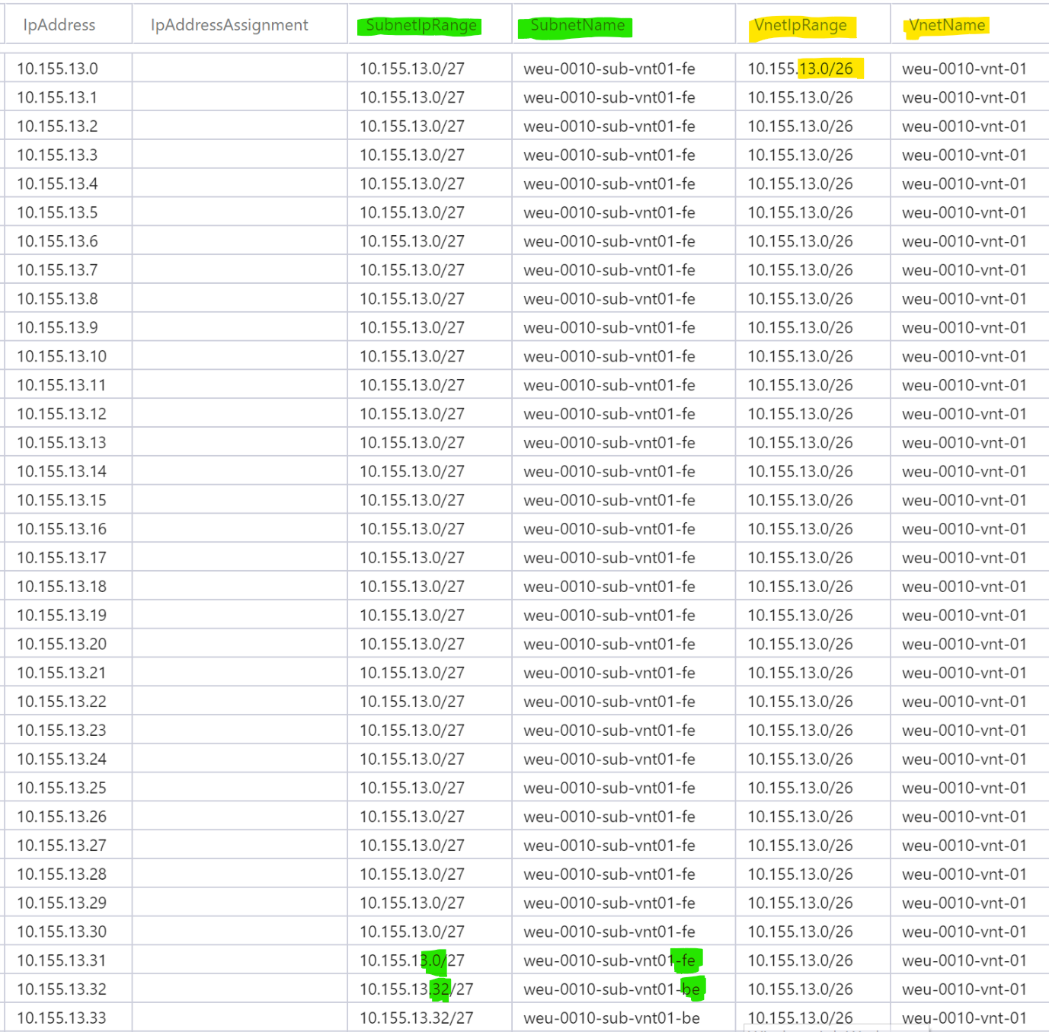

##### Address Retrieval by PowerShell

The simplest solution that can be offered is a PowerShell script that automatically retrieves an available IP address. Doing so in the Azure Portal might be a bit more complex as there is no central page that lists assigned/available IP addresses.

Need to define which approach to implement

* 1. Network Monitoring and Alerting

Except for NSG logs being forwarded to Log Analytics (see chapter *Network Security Groups*), there is no monitoring pre-configured. In the event of network related problems [Network Watcher](https://docs.microsoft.com/en-us/azure/network-watcher/) and/or [Virtual network TAP](https://docs.microsoft.com/en-us/azure/virtual-network/virtual-network-tap-overview) can be configured.

* 1. NTP

For domain joined servers the best practice is to disable TimeSync for the guest and ensure W32Time is configured to synchronize with its Domain Controller via configuring time for Type=NTP5.

For standalone, non domain joined servers the recommendation is to keep the default time configuration and have the VM synchronize with the host.

For a detailed information refer to this [documentation](https://docs.microsoft.com/en-us/windows-server/networking/windows-time-service/accurate-time#azure-and-windows-iaas-considerations).

* 1. Resource Groups, Access Control, Policies

Two Resource Groups are used in the networking space, one for Networking (e.g. weu-co-rsg-network-01) and another for Security (e.g. weu-co-rsg-security-01).

One AD Group is configured with the role Owner on the Networking Resource Group and another AD Group as Owner on the Security Resource Group.

There is no RBAC configured on individual Resources in these Resource Groups.

##### Inherited Access from Subscription

The access inherited from Subscription level (see chapter *4 RBAC*) is adjusted as follow:

Service Administrator: Owner -> Read-only

Co-administrator: Owner -> Read-only

Automation: Owner -> no adjustment

Azure Firewall need to be deployed into the same Resource Group as the VNET to which they are attached. This would break the above model in that Firewalls are assigned to a different Resource Group from network Resources. A possibly workaround would be to Resource level RBAC.

##### Resource Locks

CanNotDelete [Resource Locks](https://docs.microsoft.com/en-us/azure/azure-resource-manager/resource-group-lock-resources) are configured for all Resources in these Resource Groups. This adds another layer of protection from accidental deletion, as the Resource Lock needs to be removed prior to deleting a Resource.

##### Policies

Refer to chapter *5 Policies*.

Is this separation OK, which AD/AAD groups need to be assigned?

* 1. Route Tables

[Route Table](https://docs.microsoft.com/en-us/azure/virtual-network/tutorial-create-route-table-portal) allow for the configuration of [custom routes](https://docs.microsoft.com/en-us/azure/virtual-network/virtual-networks-udr-overview), used to overwrite or append the [VNET System Routes](https://docs.microsoft.com/en-us/azure/virtual-network/virtual-networks-udr-overview#system-routes) that are created by default.

For each VNET a default is created, with no routes configured. Custom routes are used e.g. in conjunction with routing traffic to firewalls. This default Route Table is associated with the Frontend, Backend and Management Subnets.

1. Automation Framework

This chapter addresses how the deployment of Azure resources is automated. The focus is on deployment of these Resources from a Service Request point of view and no so much from CI/CD pipeline approach. The following chapter illustrates the differencing requirements of these two approaches and how they can be overcome.

* 1. CI/CD vs. Service Request

One fundamental issue that needs to be addressed is the deployment of resources into Azure and the focus of the different stakeholders.



##### CI/CD Pipeline

In a CI/CD pipeline, developers deploy the required Azure development Resources using a combination of Visual Studio or similar and the Azure portal.

The build of the Azure integration Resources is performed by use of IaC that is retrieved along with the application code form the repository. The same applies to the deployment in production.

##### Service Requests

The Service Request (SR) approach is based on requesting Azure resources in an SR Portal which triggers the deployment to Azure using IaC in Azure Automation. The same framework is also used for scheduled or manually triggered housekeeping jobs.

##### Topics to be addressed

Below are some topics listed that illustrate why a one size fits all approach might not be feasible. They also illustrate why existing on-premise based CI/CD pipelines using OS/Containers might not be applicable one-to-one to PaaS.

###### Deployments without Code/Build

While in a traditional IaaS environment the focus is on deployment of code to an OS, this will change as more PaaS are consumed. Some PaaS resources no longer require code but are limited to configurations, e.g. Cognitive Services. Other PaaS resources require some form of code but no build process, e.g. Azure Functions which integrate directly with repositories.

###### Developers Preference vs. Operations Requirements

Developers prefer to perform any deployment of Azure Resources directly out of their development environment. This offers them most flexibility and highest productivity.

The operations teams prefer a controlled, consistent and thus automated deployment of resources. This ensures the operational responsibilities such as SLAs, financials, security, backup/restore can be met.

###### Complex deployments

More complex deployments involving e.g. Application Gateways, Firewalls or Custom Routes might be too complex to perform out of a CI/CD pipeline. This is often an issue when the development environments are less complex then production environments, e.g. lacking HA/DR capabilities.

###### Re-use of Resources

Certain IaaS and PaaS resources might be used by more than one business application, which might complicate the deployment. Examples are Cognitive Services or Cosmos DB.

###### Differing Environment

The Azure Resources required by a business application might differ between environment. While in the development environment e.g. performance or availability infrastructure configurations are not required, they are so in integration and production. This leads to different configurations across the environments.

##### Solution

The solution to address above topics is to implement a framework that combines the requirements of development and operations into a flexible solution.

The advantage of this approach is that development is not delayed or hindered (in terms of Azure Resource types available). At the same time infrastructure engineering can ensure in a timely manner that operational aspects are considered adequately.



1a Developers provision instances of the required Resource Types in the Development[4] Subscription using whatever tools they prefer. They also create the required IaC artifacts.

1b If the developers use a Resource Type that hasn’t yet been operationalized, infrastructure engineering will operationalize it in the Sandbox Subscription. The result is a Service Specification and the corresponding IaC artifact.

2 Compare the two IaC solutions and determine which ones are offered in the Integration and Production Subscription.

3 The option chosen for the deployment of Azure Resources depends on the project and Azure Resource Types. It could also be a combination of options that is used. Preferably only one option is implemented per Azure Resource type.

3a Azure Resources are deployed using IaC sourced along with the application code from the application repository.

3b Build and deploy functions in the CI/CD pipeline trigger Azure Automation runbooks to deploy the required Azure Resources. They could also trigger Service Request in the SR Portal as both 3b and 3c are based on the same automation solution.

3c Service Requests are used to deploy the required Azure Resources prior to triggering the CI/CD pipeline.

Is an alignment with an existing CI/CD implementation required, or can we dismiss all this and focus on Azure Automation?

* 1. Resource Deployment

Any deployment of new services or the changing of existing services (incl. decommissioning) should be executed by using Service Requests (SR) or Change Requests (CR). This does not apply to services that are deployed one-off in a project type manner, such as the network infrastructure in a Subscription or connectivity to on-premise.

Following illustration provides an overview of a generic framework. They key is to differentiate the three layers in the architecture, reducing dependencies without compromising functionality.

The ITIL Framework is closely integrated with the CMDB as most of the ITIL type actions require data stored in the CMDB – Resource Group selection for Service Requests, CIs attached to incidents etc..

The automation should be an agnostic framework that essentially is a central connection point for all involved components. The automation needs to natively support PowerShell as well as Web Services. Another requirement is stateful job execution and a hybrid model for workflow execution.



* 1. Technical Implementation

Below diagram illustrates a technical implementation design of the architecture outlined in the previous chapter. 

Azure Automation is used in conjunction with the existing Service Management portal and the CI/CD framework. The automation of the deployment process is required for the following reasons:

Speed: Speed and simplicity are essential to drive the adoption of the offered Services. With an automated, service catalog integrated deployment, users will opt for the officially sanctioned Services instead of building their own custom-built solutions.

Consistency: Only automated deployment ensures consistent configurations, complying with security and financial requirements.

Integration: With automated deployment, not only are individual Resources deployed but they are also integrated into the overall fabric such as monitoring, backup and security.

Change: With little extra effort Change Requests can be implemented, in addition to the initial deployment. This will allow for the change of existing configurations by executing a simple Service Request.

* + 1. Process

Below process definition illustrates the generic implementation pattern that is used for all Service Request implementations. There are two sub-processes, for the approval and the actual execution of a Solution.



##### Approval Process

The approval process for Service Requests is covered by standard ITIL portal functionality.

This process illustrates the implementation of technical approvals. This type of approval might be required, e.g. if a large PaaS is requested requiring the approval of Engineering & Operations.



* + 1. Hybrid Runbook Worker

All Runbooks are executed on a [Hybrid Runbook Worker](https://docs.microsoft.com/en-us/azure/automation/automation-hybrid-runbook-worker). This offers the following advantages:

* No Runbook execution in cloud – (optionally singed) Runbooks executed on-premise
* Access to on-premise resources behind firewalls
* Execution from a domain joined server, e.g. to enable PowerShell remoting
* Full control over the server on which Runbooks are executed
* Use of AD or local Windows user to execute Runbooks
* Runbooks [TEC0007-ExportPowerShellModules](https://github.com/fbodmer/AzureGovernance/wiki/TEC0007) and [TEC0008-ImportPowerShellModules](https://github.com/fbodmer/AzureGovernance/wiki/TEC0008) to automate PowerShell Module release process.



The Microsoft Monitoring Agent (MMA) operating the Azure Agents is connecting the Hybrid Runbook Worker to the Azure Automation. MMA is running under the System process.

The Runbooks are executed in a sandbox (Orchestrator.Sandbox.exe) on the Hybrid Runbook Worker. By default, this process is running under System, but could be configured to run under any user.

* + 1. Accounts

Below diagram illustrates the user types required, where users are stored and what roles they are assigned in the context of the individual resources.



* + - 1. User Types

The following user types are required for the Azure Automation framework:

##### Personal Admin User

Standard Personal Admin Users as they are currently in place at RCH. These users will be configured as administrators on the Hybrid Runbook workers as PowerShell development requires an administrator role.

Depending on the Azure Subscription these users will be configured with a Contributor or an operational role on Azure Automation – refer to *8.6 Access Control and Operational Responsibility* for details.

Access granted to the Azure Resources depends on the Resource Group to which a Resource is deployed.

##### Technical User Azure

This is a technical user that is instantiated in AD using the standard IAM process and federated to AAD. It is important to understand that this user is used in Azure only and has no rights in the on-premise environment.

In addition, the user is configured as a Credentials asset in Azure Automation. This allows for retrieval of the user during Runbook execution. It is that user that is employed for activities targeted at Azure.

This user can’t be configured with [MFA enabled](https://docs.microsoft.com/bs-latn-ba/azure/active-directory/authentication/howto-mfa-userstates#change-the-status-for-a-user). If a mail account is configured, this account could be used to send mail messages from Runbooks. Otherwise a mail-only technical user is to be configured.

##### Technical User OnPrem

This refers to existing technical users that are required for access to on-premise resources. If such a user is required in a Runbook it must be configured as a Credentials asset in Azure Automation. This allows for retrieval of the user during Runbook execution. It is that user that is employed for activities targeted at on-premise resources.

##### RunAs Accounts

Azure Automation [RunAs Accounts](https://docs.microsoft.com/en-us/azure/automation/manage-runas-account) are configured for all Azure Automation Accounts as they are used for various housekeeping purposes. However, all Runbooks on the Hybrid Runbook Workers are executed by users stored in Azure Automation Credential Assets. This user is either an AD or local Windows users configured as Windows Administrator on the Hybrid Runbook Worker.

The PowerShell Module [AzureAutomationAuthoringToolkit](https://www.powershellgallery.com/packages/AzureAutomationAuthoringToolkit/0.2.3.9) needs to be installed under the ‘current user’. It can't be installed along with the other Azure Modules. This controlled installation of PowerShell Modules is simplified by not using RunAs Accounts.

* 1. Development Environment
     1. Integrated Development Environment (IDE)

PowerShell ISE with the Azure Automation Add-on is used as the development environment. Optionally [ISESteriods](http://www.powertheshell.com/isesteroids/) is used to enhance developer productivity.

All development is performed in PowerShell ISE, testing can be executed locally on the workstation or remotely in the Azure Automation Account. The Azure Automation ISE Add-on is used to synch the local development environment on the developer’s workstation. There is no direct connection between GitHub and the development Azure Automation Account.

GitHub Desktop on the developer’s workstation is used to synch between GitHub and PowerShell ISE. Hence the developer’s workstation is the integration point between GitHub and the development Azure Automation Account.

* + 1. Development, Integration and Production Environments

Separate Azure Automation Accounts are used for development, testing and production. The development and testing of new Runbooks are performed in the Sandbox Subscription – not in the Development Subscription. As Runbooks mostly act against Azure Resources there is the potential to accidentally impact resources that are used for another purpose. In the Development Subscription this would have an impact on development activity. Another advantage of using the Sandbox Subscription is the freedom to work with any Azure Resource type and not being hindered by Azure Policies.

The Azure Automation instance in the Core Subscription is used to deploy to all other Subscriptions. There is only one productive Azure Automation instance being operated.



* + - 1. CI/CD

This framework can be integrated into a CI/CD pipeline, although the automated testing would require some additional effort.

The Runbooks are imported from the GitHub Master branch. This is performed by the Runbook TEC0004-GitHubImport. Following are the reasons why the built-in Source Control functionality is not used:

* Runbooks deleted in GitHub are not deleted in the Azure Automation Account
* Deleting Runbooks prior to import from GitHub
* Special handling for Runbooks with Webhooks
  + - 1. Components, Users, Credentials

Below diagram illustrates the individual components required in the development environment. The development can be performed both on the developer’s workstation as well as on the Hybrid Runbook Worker. The advantage of using the later, is identical development and runtime environments.

The Runbooks and Azure Automation Assets (variables and credentials) are synchronized between PowerShell ISE and Azure Automation. This synchronization must be triggered by the developer and password of credentials must be entered locally in PowerShell ISE.

As outlined above, code is synchronized between PowerShell ISE and GitHub using GitHub desktop. There is no synchronization between GitHub and the Azure Automation development account. The CI/CD process is used to deploy Runbooks from GitHub to the non-development Azure Automation Accounts.



Is an integration with Git implemented, can an existing Git/TFS instance be used?   
A diagram should be added that illustrates the mapping of DEV/TEST/PROD instances for the different frameworks and how they communicate. Example: the development instance of the Service Catalog should not be able to trigger Runbook in the production instance of Azure Automation.

* + 1. Branching Model

The following diagram illustrates a possible branching model and the associated Azure Automation accounts.

Master: Only the Master branch is released into the Production Azure Automation account.

Hot Fix: Hot fixes are implemented and tested in the Test account and pushed into the Master branch.

Bug Fix: Bug fixes are implemented, and unit tested in the developer’s individual accounts. After pushing to the Develop branch, the integration testing is performed in the Test account. After that the Develop branch is pushed to the Master branch for release into Production.

Develop: The Develop branch in the Test account is used for integration testing of the individual bug fixes and new features.

Feature: New features are handled the same as bug fixes. Developers work in their own Development account.

All development and testing is performed in the Sandbox Subscription as to not impact the production workloads in the Infrastructure and Standard Subscriptions. From an automation point of view only the Sandbox Subscription is not productive.

The automation in the production environment is performed from the Core Subscription.



* 1. Runbook Design

Refer to [this and related pages](https://github.com/fbodmer/AzureGovernance/wiki/Runbook-Overview) for details on the Runbook Design and Runbook Naming.

* 1. Access Control and Operational Responsibility

##### Supported Roles

The following built-in roles are supported for Azure Automation (technical roles such as for monitoring are not listed): [Owner](https://docs.microsoft.com/en-us/azure/active-directory/role-based-access-built-in-roles#owner), [Reader](https://docs.microsoft.com/en-us/azure/active-directory/role-based-access-built-in-roles#reader), [Contributor](https://docs.microsoft.com/en-us/azure/active-directory/role-based-access-built-in-roles#contributor)

##### Operational Management

The Owner role is assigned to the Automation Operate team, the automation account and the Automation Developers, all other roles are not applied.

Developers have access to the Sandbox and Integration Subscriptions only. Access to the Production Subscription is reserved for the Automation Operate team. The Automation Account needs access to all environments. This is required for the runbooks that automate the Software Life Cycle management, e.g. import/export to/from Git.

##### Resource Usage by Owner

There is no typical business owner, Azure Automation accounts are jointly owned by Developers and Operate.



Identify the individual AD/AAD Groups.

* 1. Automation Monitoring and Alerting

The monitoring of executed jobs is performed via the Azure Portal and in Log Analytics. For this reason job information from Azure Automation is [forwarded to Log](https://docs.microsoft.com/en-us/azure/automation/automation-manage-send-joblogs-log-analytics) Analytics.

Alerts are configured in Log Analytics to notify the respective teams of failed runbooks. Details are captured in the respective Service Specification for the Resource Types.



Is this implemented or is monitoring by users in the Azure Portal sufficient?

* 1. Security Overview

Following exhibit illustrates the security view on the overall architecture and access types.



1. Monitoring Framework
   1. Overview

##### Metrics and Logs

Azure differentiates between [Metrics](https://docs.microsoft.com/en-us/azure/monitoring/monitoring-data-collection#metrics) and [Logs](https://docs.microsoft.com/en-us/azure/monitoring/monitoring-data-collection#logs), both of them are generated by the monitored components. While Resource Metrics are automatically forwarded to [Azure Monitor](https://docs.microsoft.com/en-us/azure/azure-monitor/overview), the forwarding of Logs needs to be configured. This involves the creation of a Log Analytics instance and the configuration of the individual Resources to forward log entries to that Log Analytics instance.

Metrics and Logs can be combined by copying the metrics data into a Log Analytics instance. Multiple Log Analytics instances can be created and subsequently combined in reports, dashboards etc.

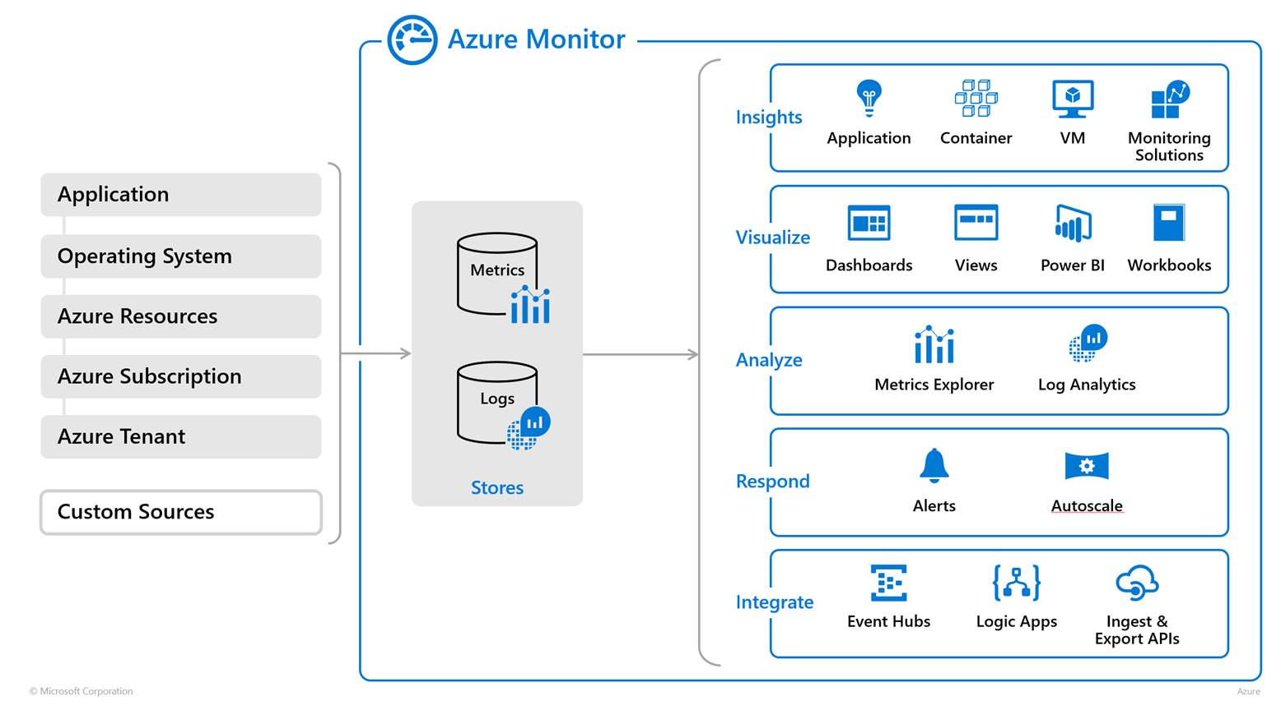

* 1. Architecture

The monitoring framework outlined in this chapter is universally applicable for all resources operated in Azure. It also serves as the integration point into on-premise monitoring solutions.

How individual Resource Types are integrated into this framework is outlined in the respective Service Specification.

* + 1. High-level Component Overview

The following diagram depicts a high-level overview of the components required for the monitoring framework.



##### Resource Level Monitoring

Each resource type deployed in Azure provides its own, specific monitoring functionality. This includes dashboards, log search and alerting in the Azure portal. While the metrics are automatically available in Azure Monitor, the forwarding of logs to a Log Analytics instance and with that to Azure Monitor needs to be configured. Some Resource Types provide monitoring data that is not by default available in Azure but must be retrieved by installing agents (VMs) or being exported to Azure (SQL).

The main user group for the monitoring functionality on resource level are SME such as DBAs that require detailed information and real time data.

##### Azure Monitor

Azure Monitor offers the capability to consolidate the monitoring of Azure resources. In addition to offering a universal log sink, Azure Monitor provides alerting and Management Solutions.

The main user group for Azure Monitor are individuals that require an overview of multiple resources operated in Azure and correlations between resources. Azure Monitor will also be used as an integration point to on-premise monitoring solutions.

###### Management Solutions

Management solutions extend the functionality of Azure Monitor by providing packaged management scenarios that can be added. In addition to [solutions provided by Microsoft](https://docs.microsoft.com/en-us/azure/log-analytics/log-analytics-add-solutions), partners and customers can create management solutions to be used in their own environment or made available to customers through the community. These Management Solutions mostly use data in Log Analytics in combination with queries to create Reports and Dashboards. Some also use Azure Automation to trigger activities based on query results.

##### Azure Cost Management

Azure Cost Management provides the necessary financial information to enable proper cost management. All resources in Azure are tagged to ensure alignment with the financial model. Alerts can be configured to notify users in case of unexpected cost being incurred.

Cost Management is not further discussed in this chapter – see chapter *11 Financial Control*

* + 1. Roles and User Groups

The framework is addressing the requirements of all relevant user groups.

SME: Subject Matter Experts in the different technology domains, such as databases, messaging, machine learning.

Global Ops: Operate team monitoring the whole environment on a single pane of glass.

App Operate: Business application operate teams, focusing on end-to-end monitoring of the business application.

Security: Enforcement of security related policies, tracking of violations.

Financials: Tracking of financial expenditure in Azure.



##### Azure Resource Level Monitoring

This covers the configuration of monitoring and alerting on individual resources such as databases. As this is consumed by the SME (Subject Matter Experts) only, they are responsible for the configuration of the dashboard, reports and alerts. The central monitoring team is not involved.

Alerts on this tier are not integrated into the global alerting system. The target audience for these alerts are SMEs.

Ideally this functionality could be captured in the existing, on-premise monitoring tools used by the individual SME. The design of the individual resource types (in the Service Specifications) outlines if an integration into the existing monitoring tools is possible or if the SME need to work with the Azure resource level monitoring in the Azure portal. This might be the case e.g. if resource types are used that are not available on-premise. Example: an on-premise monitoring tool might not be able to monitor an Azure Logic App instance.

##### Azure Monitor

Azure Monitor consolidates the monitoring, reporting and alerting for all resources in Azure. Dashboards, reports and alerts are configured that are covering a certain resource type (e.g. all Cosmos DB resources) or multiple resource types (e.g. all resources of a business application). Examples:

* The DBAs have a consolidated view of all the databases operated in all Azure subscriptions.
* The Application Operate team has and end-to-end view of all resources deployed for a specific business application, such as DB, DWH, ETL jobs.

The monitoring and alerting in Azure Monitor are highly standardized, e.g. the same for all databases. This contrasts with the monitoring and alerting on resource level. On that level the monitoring and alerting is more customized. A DBA might choose to configure additional monitoring and alerting, only applicable during a deployment window.

##### Azure Cost Management

It is up to financial controlling to configure the reports required for cost management. At this point there are no plans to integrate the financial data into existing on-premise systems.

On notable exception is the configuration of alerts for Resource Groups – for details refer to ‘Service Specification – Resource Groups’.

* + 1. Access Panes

The following diagram adds the access panes to the monitoring architecture overview. For each user group there are multiple access panes:

Single pane: This is not an access pane per-se but indicates if the access pane offers a single pane. This is the case if all resources of a certain type are captured in a single tool - e.g. a DBA can see all databases in Azure Monitor.

Reporting: Data is generally lagging a couple hours behind their creation time stamp. This is mostly for reporting purposes, such as cost, SLA or inventory.   
Data is commonly analyzed using a time frame of a couple days/weeks/months.

Near time: Data is lagging several minutes behind their creation time stamp. This is useful for operational purposes, especially if a big picture is required. E.g. correlation of database and network data.   
Data is generally analyzed using a time frame of a couple hours.

Realtime: Data is available in real-time, as reported by the resource. This is mostly for troubleshooting and investigation on an individual resource.   
Data is generally analyzed using a time frame of a couple minutes.



##### IaaS vs. PaaS

A distinction must be made between IaaS and PaaS services. Resources types that are available as IaaS and PaaS need to be combined from a monitoring point of view. E.g. a DBA needs to monitor all SQL instances independent of them being implemented as IaaS or PaaS.

Other resource types such as Azure Stream Analytics are available as PaaS only. There is no OS type agent to be installed to gather information such as with IaaS.

* + 1. Alerting

The following diagram adds the alerting to the monitoring architecture overview. There are two different types of alerts.

Standardized: These alerts are identical for all instances of a Resource Type and are configured along with the deployment of a resource.

Customized: Customized alerts are configured ad-hoc. They address a very specific, mostly temporary operational need. The configuration of these alerts is mostly performed by the SME.



##### De-duping

A special design pattern is required for the de-duping of alerts. The requirement is to only send an alert once when the defined condition triggers the first time. Subsequent alerts should be suppressed.

This is implemented by ensuring that a condition didn’t trigger in the previous period. In below example the subscription quote is monitored. An alert is triggered if the quota is over 9. Meaning an alert is triggered in the second reporting period, but not the third.



* 1. [](https://github.com/fbodmer/AzureGovernance/wiki/PAT0300)Implementation

A differentiation is made between generic monitoring and Resource Type specific monitoring.

* + 1. Generic Monitoring

The generic monitoring covers all resources that are deployed when a Subscription is provisioned. This is essentially the monitoring of the Resources outlined in this document.

There are two Log Analytics instances in the Core Subscription. One to collect generic monitoring data and one for security relevant data. Refer to the following chapters for details:

##### cusweucocore01

* Chapter *2.9 Subscription Monitoring and Alerting*
* Chapter *7.7 Automation Monitoring and Alerting*

##### cusweucosecurity01

* Chapter *3.1 AAD Monitoring and Alerting*
* Chapter *8.7 Network Monitoring and Alerting*



Is this what is to be implemented? This corresponds with what is outlined in previous chapters.

* + 1. Resource Type specific monitoring

Additional monitoring requirements are defined in the respective Service Specifications or the Business Application operations specification. The respective specifications cover security, availability, performance and financial monitoring. Alerting is also covered in this context.

##### Security Monitoring

Covers all security related monitoring such as out-of-band changes, firewall changes etc.

Defines what alerts are issued based on what conditions.

##### Availability and Performance Monitoring

Monitor any topic that could have an impact on performance or availability, such as failure of a service, response times, exhaustion of limits available in a configured SKU.

Defines what alerts are issued based on what conditions.

##### Financial Monitoring

Financial monitoring is configured on Resource Group level only and is therefore listed in that Service Specification only.

* + 1. Integration with on-Premise

One of the basic principles is that Azure monitoring data is not directly forwarded from individual Resources to on-premise monitoring tools. Instead a consolidation is performed using Azure Monitor. This approach is selected for the following reasons:

* The amount of monitoring data generated by Resources in Azure is too voluminous for forwarding unfiltered to an on-premise monitoring framework.
* Most events generated by Resources in Azure are not known to on-premise monitoring tools, as nothing comparable exists outside Azure. Azure Resources that generate events that are known to on-premise monitoring tools are limited to a subset of events related to VMs and SQL PaaS.
* An increasing number of Management Solutions is becoming available. These solutions are integrated into Azure Monitor and take advantage of data and tools available in Azure. Nothing comparable is available on-premise.

Instead of forwarding unfiltered Azure monitoring data to the on-premise monitoring framework, data in the Log Analytics instances is consolidated by use of reporting/alerting functionality and forwarded to the on-premise tools.

In cases where the on-premise monitoring framework requires Azure monitoring data, it is defined in the Service Specification.



Need to define in detail what is required. Best is when requirements are defined based on existing on-premise implementation. These requirements can then be mapped to Azure.

1. Financial Control

Financial control is subdivided into different activities:

* *Cost Avoidance* helps prevent the erroneous deployment of costly Resources.
* *Cost Monitoring* compares actual cost with an established budget to detect unwanted deviations.
* *Cost Allocation* is the process of allocating the cost incurred in Azure to different cost centers.
* *Cost Optimization* aims at reducing cost by optimizing the Resource Types used and Resource deallocations.
  1. Cost Avoidance

To avoid unnecessary cost, policies are configured that prevent the (accidental) use of expensive Resources (see *5 Policies*).

[Azure Marketplace](https://azuremarketplace.microsoft.com/en-us/marketplace/) purchases can be enabled or disabled in the EA portal ([see page 12](https://azureonboardingguide.blob.core.windows.net/gov/Microsoft%20Azure%20Government%20-%20Indirect%20EA%20Customer%20Onboarding%20Guide.pdf)). It is important to understand that this is performed on enrollment level and therefore is applied to all Subscriptions. A [request to improve this functionality](https://feedback.azure.com/forums/216369-azure-marketplace/suggestions/30953149-enhance-the-ea-azure-marketplace-configuration-en) has been submitted. For the time being the only option to limit Marketplace purchases is to disable the functionality in the EA portal and temporarily enable it to deploy a Marketplace offering.

* 1. Cost Monitoring

[Azure Cost Management](https://docs.microsoft.com/en-us/azure/cost-management/overview-cost-mgt) provides functionality to monitor, analyze and optimize cost incurred in Azure.

* + 1. Budgets and Alerting

The [Budget](https://docs.microsoft.com/en-us/azure/cost-management/tutorial-acm-create-budgets#create-a-budget-in-the-azure-portal) functionality is available on Subscription and Resource Group level. This allows for the monitoring of cost and the issuing of alerts.

###### Subscription Level

An alert on Subscription level might be of interest for the Cloud Manager. But this is likely limited to Special Subscriptions that have a spending limit on Subscription level. For the Standard Subscritpions and Infrastructure Subscriptions there are no spending limits on Subscription level, but on Resource Group level. Therefore, an alert on Subscription level might not be too useful, particularly since the Cloud Manager should monitor cost daily anyway.

###### Resource Group Level

Alerts on Resource Group level help the Owner of the Resource Group control the budget and avoid unwanted, costly deployments or configurations.

One drawback of the budget functionality is that it triggers alerts when a percentage threshold of the budget is reached. This approach won’t protect against erroneous deployments of Resources that result in unwanted cost. With a threshold set at 80% no alert will be issued if 70% of the budget is consumed on the first day of the month.

Budget alerts are based on daily data and can therefore not protect against intra-day provisioning mistakes.

A better solution might be to use the framework outlined in the following chapter to create the alerts based on queries in Log Analytics.

* 1. Cost Allocation

##### Data Sources

Azure is providing three kinds of billing information that are relevant in this context:

Billing Period: Billing period with start and end dates – Invoices are based on Billing Periods  
Consumption: Daily breakdown of consumed quantities and estimated charges,   
 intra-day data is lagging by a couple hours.  
Invoice: Invoice information - the actual invoice can be downloaded using provided URL  
Price Sheet: Provides applicable rate for each meter

Below diagram illustrated the relationship between Invoices, Price Sheets and Consumption data. The cost allocation is performed based on Consumption data. This is since invoices are retrieved in PDF format and can’t be used for processing and Consumption data contains more detailed information.



##### Calculation and Allocation

The Tag *Kostenstelle* on the Resource Groups is used to allocate cost incurred in Azure to the respective cost centers.

While the Consumption data is providing tags, their values provide a snapshot only. Tags changed during a Billing period are not reflected. For this reason, a configuration table is used to retrieve this data. All automated deployments are recorded in this configuration table, as are tag changes executed by tag maintenance Runbooks (see *6.3 Tag Management*).

A combination of the tags retrieved from Consumption data, current tags on the Resource Group and from the Configuration table will provide the required data to correctly allocate the cost.



##### Data Storage

Azure Automation Runbooks are used to retrieve and reconcile data from the various resources. This data is then stored in a billing Log Analytics instance in the Core Subscription. Storing this data in a Log Analytics also has the advantage that it can be used for multiple purposes, such as creating custom Dashboard for Resource Group owners (see 11.2.2 Dashboards).

##### Data Transfer

Using Queries and Alerts in Log Analytics the Cost Allocation report is created, e.g. in CSV format and provided to the target system, by use of mail, file transfer or similar.

If this is required, the file format and structure have to be defined.

* + 1. Dashboards

##### Cost Management Dashboards and Views

Cost Management offers dashboard for Cost Analysis as well as a Budget overview. For the Cost Analysis Dashboards, the scope must be set to the Resource Group in question. Limitations of this approach are that is somewhat cumbersome, and that Cost Management doesn’t offer granular access control – users can see all data in a Subscription by changing the scope.

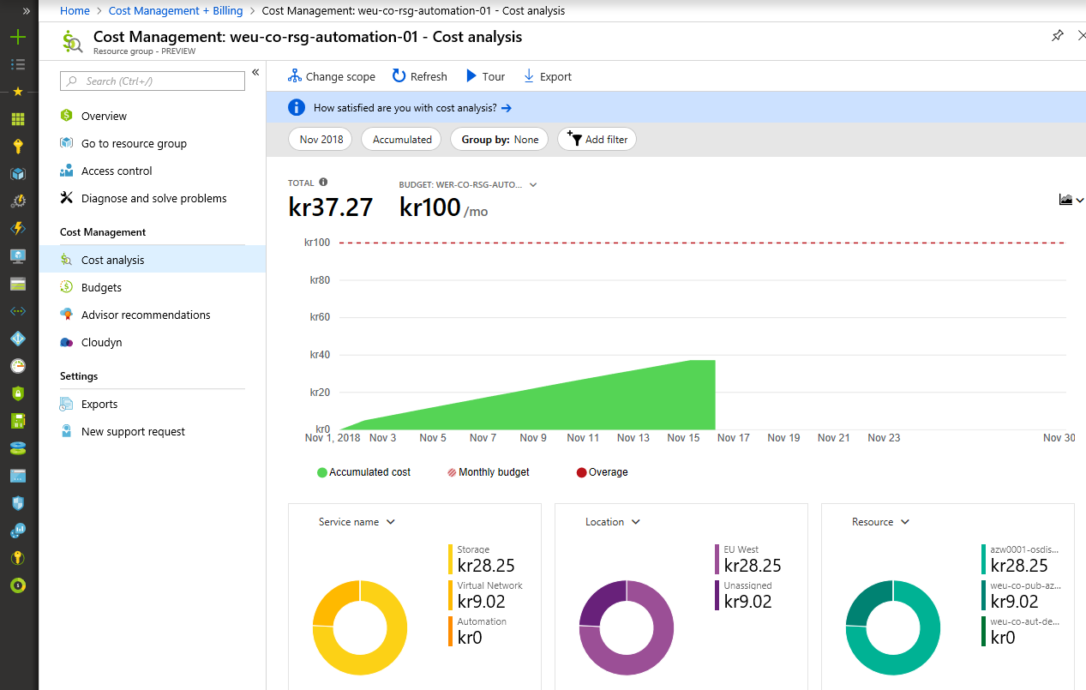

The Budget simply displays an overview of the Budget configuration and consumption as measured against the budget. Again, users have access to all Budgets.

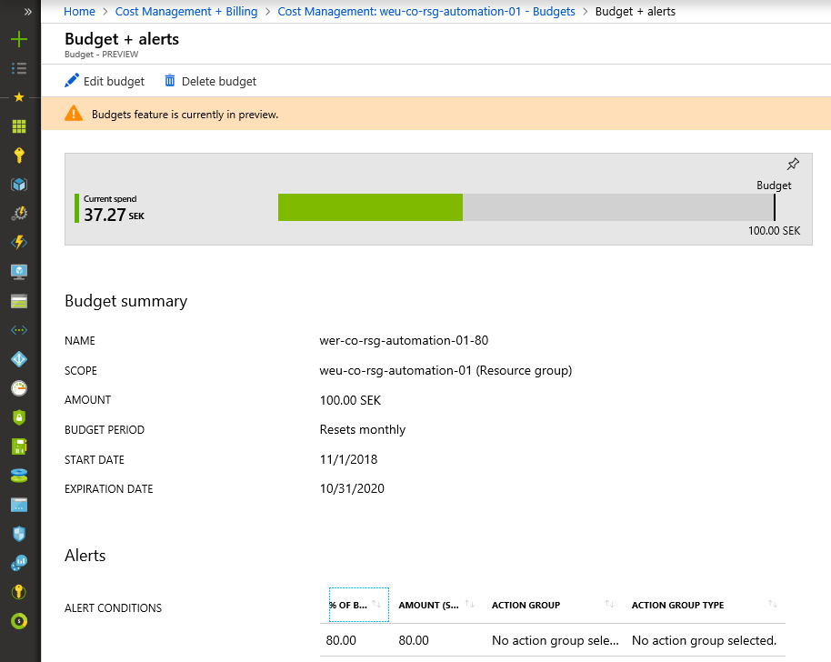

##### Portal Dashboards

A more efficient approach is to add the dashboards for cost and budget to a user’s main dashboard. Upon login to the Azure Portal the cost and budget situation for all Resource Groups is displayed.

However, this requires access rights to Cost Management. Dashboards in Azure also enable drill-down leading users to the Cost Management sections in the Portal.

This might not be feasible as it can’t be automated and users can configure their landing page to be the Dashboard or the Home page.

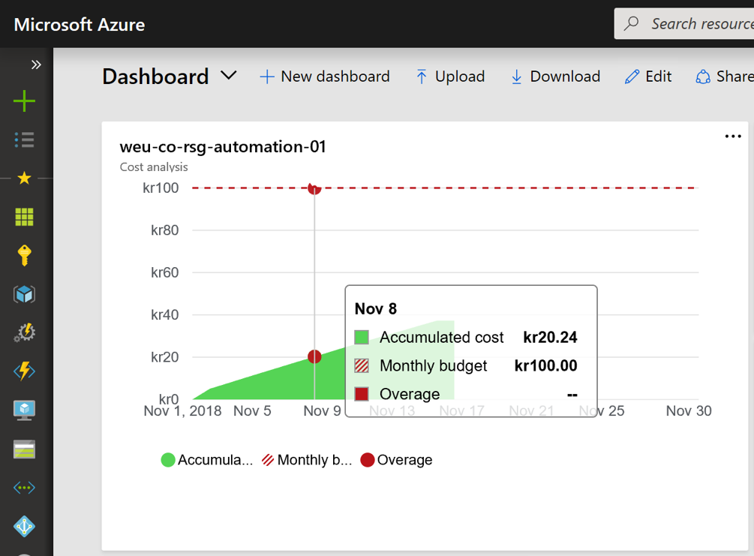

##### Custom Dashboards

Another approach that wouldn’t require access rights to Cost Management is to automatically create the Dashboards and publish them in a Markdown tile on the Dashboard or at any other location. The Runbook would involve the following steps:

1. Retrieve the billing data using the Azure Billing API (see *Data Storage*)
2. Create the charts
3. Save the charts to a location that can be assessed by the Markdown tile
4. Updated charts are displayed in Azure Portal

##### Power BI

A solution that is not based on Dashboards in the Azure Portal would involve the use of Power BI. In this approach the data in Log Analytics would be used as the basis for the Power BI reports:

1. Retrieve the billing data using the Azure Billing API (see *Data Storage*)
2. Create/run the Log Analytics Queries
3. Publish the data in the query to Power BI
4. Create Dashboards and Reports in Power BI

Access control would be provided by using row-level security on the Power BI Dataset. Currently there is no functionality available to automatically update the row-level security in the Dataset. This would have to be performed manually – each time a new Resource Group is deployed.

[](https://github.com/fbodmer/AzureGovernance/wiki/TEC0010)

Define what options is to be used and what dashboards are required.

* 1. Cost Optimization

Cost optimization is based on Cost Management Advisor recommendations as well as custom reports that are created as needed. The Log Analytics instance for billing is used for that purpose.

The cost optimization is the responsibility of the Cloud Manager, which performs this task for all deployments in Azure. Experience shows that Resource owners won’t optimize on their own, due to a lack of time, understanding or fear of implementing unwanted changes. A better approach is for the Cloud Manager to approach the Resource owner with suggested changes and potential saving resulting from these changes.

1. Security

Security topics are covered in the previous chapters as well as the individual Service Descriptions. The following chapters address some generic, universally applicable areas.

Security is addressed in detail in each Service Description, such as for Storage Accounts or Cosmos DB. For this reason, the following chapters are an overview only.

* 1. Storage Encryption (Data at Rest)

The following storage encryption technologies ensure that data is not accessibly by third parties, including Microsoft personnel that operate the Azure infrastructure. Detailed information is available in the [Azure Storage Security Guide](https://docs.microsoft.com/en-us/azure/storage/common/storage-security-guide).

##### Azure Storage Service Encryption

[Azure Storage Service Encryption](https://docs.microsoft.com/en-us/azure/storage/common/storage-service-encryption) (SSE) is enforced by Azure on all Storage Accounts and Managed Disks. While Storage Accounts support SSE with customer-managed keys this is not yet available for Managed Disks. In this context it’s important to understand that e.g. blobs in Storage Accounts are also used by different PaaS services.

##### Azure Disk Encryption

While SSE encrypts the storage containers, [Azure Disk Encryption](https://docs.microsoft.com/en-us/azure/security/azure-security-disk-encryption-overview) can be optionally used for OS level encryption. This is implemented using BitLocker on Windows and DM-Crypt on Linux.

##### Azure Confidential Computing

The [DC-Series](https://docs.microsoft.com/en-us/azure/virtual-machines/windows/sizes-general#dc-series) VMs support the SGX technology that allow for the implementation of [Azure Confidential Computing](https://azure.microsoft.com/en-us/solutions/confidential-compute/), protecting data while it’s processed in memory.

* 1. Data in Transfer

All Resource Types in Azure support or mandate the encryption of data in Transfer. Please refer to the Service Descriptions for details.

* 1. Grant Access to Microsoft Support Engineers

While Microsoft has always obtained customer consent for access, [Customer Lockbox](https://azure.microsoft.com/en-us/blog/approve-audit-support-access-requests-to-vms-using-customer-lockbox-for-azure/) provides the ability to review and approve or deny such requests from the Azure Portal. Until the request is approved, Microsoft Support Engineers will not be granted access.

* 1. Security center

This chapter needs to be added detailing how Security Center can be implemented, configured and used.

1. This is a customer business type tenant, not be confused with an O365 are Azure related tenant.
2. The manual definition of tags, possibly enforced by policies, is not likely to produce reliable results.
3. This Subnet has not yet been included in the Subnet configuration in this document
4. Non-operationalized Resource Types should only be used in Special Subscriptions, for easier legibility this is left out.